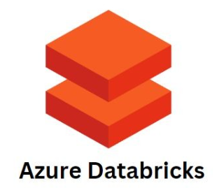



**PART - 2**

Contents

Delta Lake and Delta Tables 3

Creating Delta Table 6

Sharing Data for External Delta Table 13

Reading Delta Tables 18

Delta Table Operations 23

Delta Table Time Travel 30

Convert Parquet to Delta 39

Delta Table Schema Validation 44

Delta Table Schema Evolution 51

A Look inside the Delta Table 66

Delta Table Utilities and Optimizations 76

Incremental Data Ingestion 99

Architecture and the Need for Incremental Ingestion 99

Using Copy into Manual Schema Evolution 103

Using Copy Into , scewith Automatic Schema Evolution 109

Streaming Ingestion with Manual Schema Evolution 115

Streaming Ingestion with Automatic Schema Evolution 120

Introduction to Databricks Autoloader 124

Autoloader with Automatic Schema Evolution 125

Delta Live Tables 134

Understand DLT Use Case Scenario 137

Setup DLT Scenario Dataset 140

Creating DLT Workload in SQL 143

## Delta Lake and Delta Tables



|  |  |
| --- | --- |
|  | We will learn to work with Delta Lake and Delta Tables. We already know that Apache Spark lacks the acid transaction capabilities, and those AC transaction capabilities are brought to spark using Delta Lake. Open source project and Databricks platform combines Delta Lake with the Apache Spark and brings it together Pre-integrated ready to use in the Databricks platform. So we will go through the Delta Lake and Delta table capabilities, try to understand how can we leverage those capabilities and understand Delta Lake and Delta Table properly. |

We will start with the introduction to Delta Lake and Delta Tables. So we understand what it is. And then we will go through with some demos and examples on how to work with the Delta tables. Then we will start exploring delta table capabilities and features, for example versioning and time travel. Then we'll go with the schema validation and a schema evolution capabilities of Delta table will also learn delta table internals and understand how delta tables are designed and work what happens behind the scene. And finally, we will conclude this section with the Delta table optimization capabilities.

|  |  |
| --- | --- |
|  | We will try to understand what is Delta Lake. I will give you a quick introduction about the Delta Lake and its capabilities and features. So let us start with a simple question. What is Delta Lake? Delta Lake is an open source project. It is not part of the Apache Spark. It's separate. It's an independent open source project. And to get more details about the open source project, what it is, what it can do, you can visit the Delta Lake open source project, website. So let me open my browser and search for Delta Lake. And hopefully the first result will be, delta.io website, which is the home page or the website for the Delta Lake project.  So Delta Lake is an open source project managed by Linux Foundation. And what it is, Delta Lake is an open source storage framework that enables building a lake house architecture with compute engines including spark, Prestodb, Flink, Trino and Hive, and APIs for Scala, Java, Rest and Python. |

|  |  |
| --- | --- |
|  |  |

So in summary, Delta Lake is an open source storage framework which works between the distributed data processing engine and the storage layer. It works in between. So in your case, your data processing engine or distributed data processing engine is Apache Spark and your storage layer is your cloud storage. So Delta Lake sits in between these two things. And it's not like that. Delta Lake is, available only for Apache Spark. It is available for a lot of other open source technologies. And, people are adopting it. So let's try to quickly understand what are the different capabilities and features that Delta Lake brings.

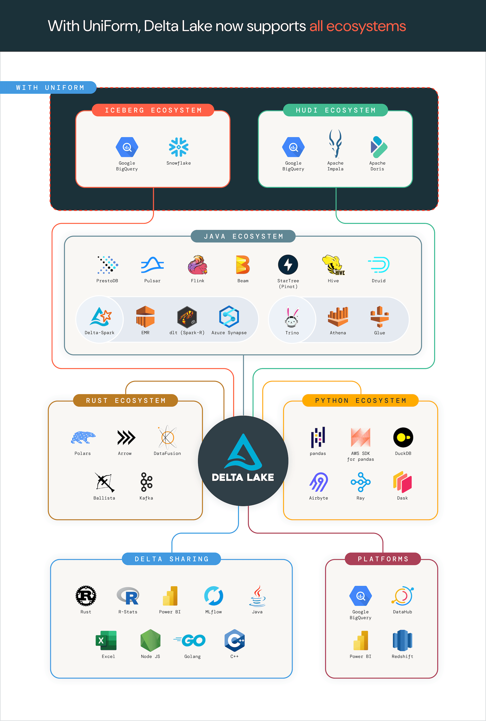



So what is Delta Lake? Delta Lake is an open source storage framework.



What are the key features or what are the most important capabilities that Delta Lake brings on the table? It brings ACID transactions to your distributed data processing framework. In our case, we are using Apache Spark.

|  |  |
| --- | --- |
|  | So it brings ACID transaction capabilities to Apache Spark. It allows us to delete, update and merge data into the table. We know that in spark, deleting or updating data works at the file level. You have to either delete the entire file or rewrite the data file with the new data set. That's how it works in Apache Spark.  But Delta Table or Delta Lake simplifies that operation and brings delete, update, and merge statements or capabilities to Apache Spark. Delta Lake also comes with schema enforcement and evolution, so it simplifies schema enforcement and schema evolution for your tables. |

A delta lake comes with data versioning and time travel, so it automatically versions your data based on your transactions and allows you to go back in time and work with the older versions or different versions of your data. A Delta Lake simplifies streaming and batch we call it streaming and batch unification. The point is that streaming data is different when we. Collect streaming data. We collect a small amount of data, and we want to save it as quickly as possible on our storage layer. So maybe we are generating maybe 100 records or 1000 records or 5000 records every minute or every second, which is a small data set to write on the storage layer. Apache spark is supposed to be working with the huge volumes of data, so streaming is little different than the batch data. In batch data, you collect GBS of data or terabytes of data and ingest it at once. Bring it in your storage layer and start processing it. But in streaming, we usually work with the small set of data. So how do we store that data? How do we save that data? How do we manage that small, increments of data that's a little different. And delta table simplifies working with, streaming data as well as batch data. You you can consider both as same kind of data. And delta table also gives some optimization techniques, some tools that allows you to optimize your tables. So that's about the features. We will go through all these features and learn them one by one in the following lectures. But who is using Delta Lake? Is it only Apache Spark, or is it only part of the Databricks project? Who is using a Delta lake? So it's not only, Apache Spark, but even snowflake is adopting Delta Lake. Redshift is adopting Delta Lake. There are a lot of other projects which are adopting Delta Lake open source project. So, it's popular, it's open source. And for Databricks platform, it is integral part of the Databricks platform. So that's all for introduction about the Delta Lake. We will start learning more about the Delta Lake, how to use it and understand all those features step by step.

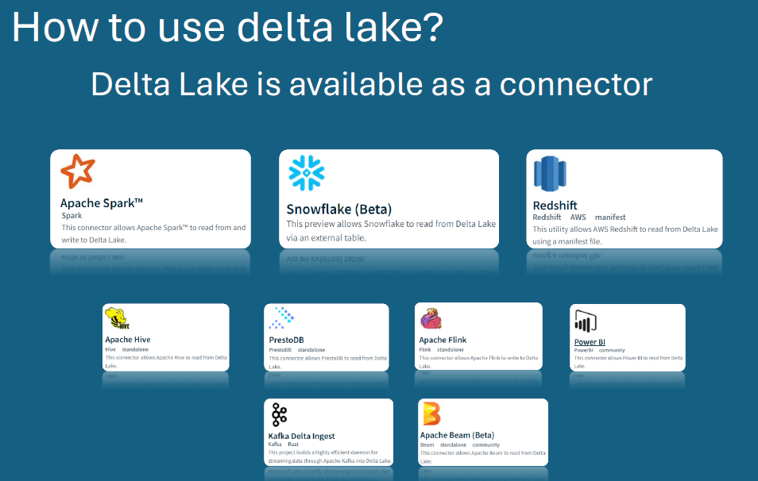

### Creating Delta Table

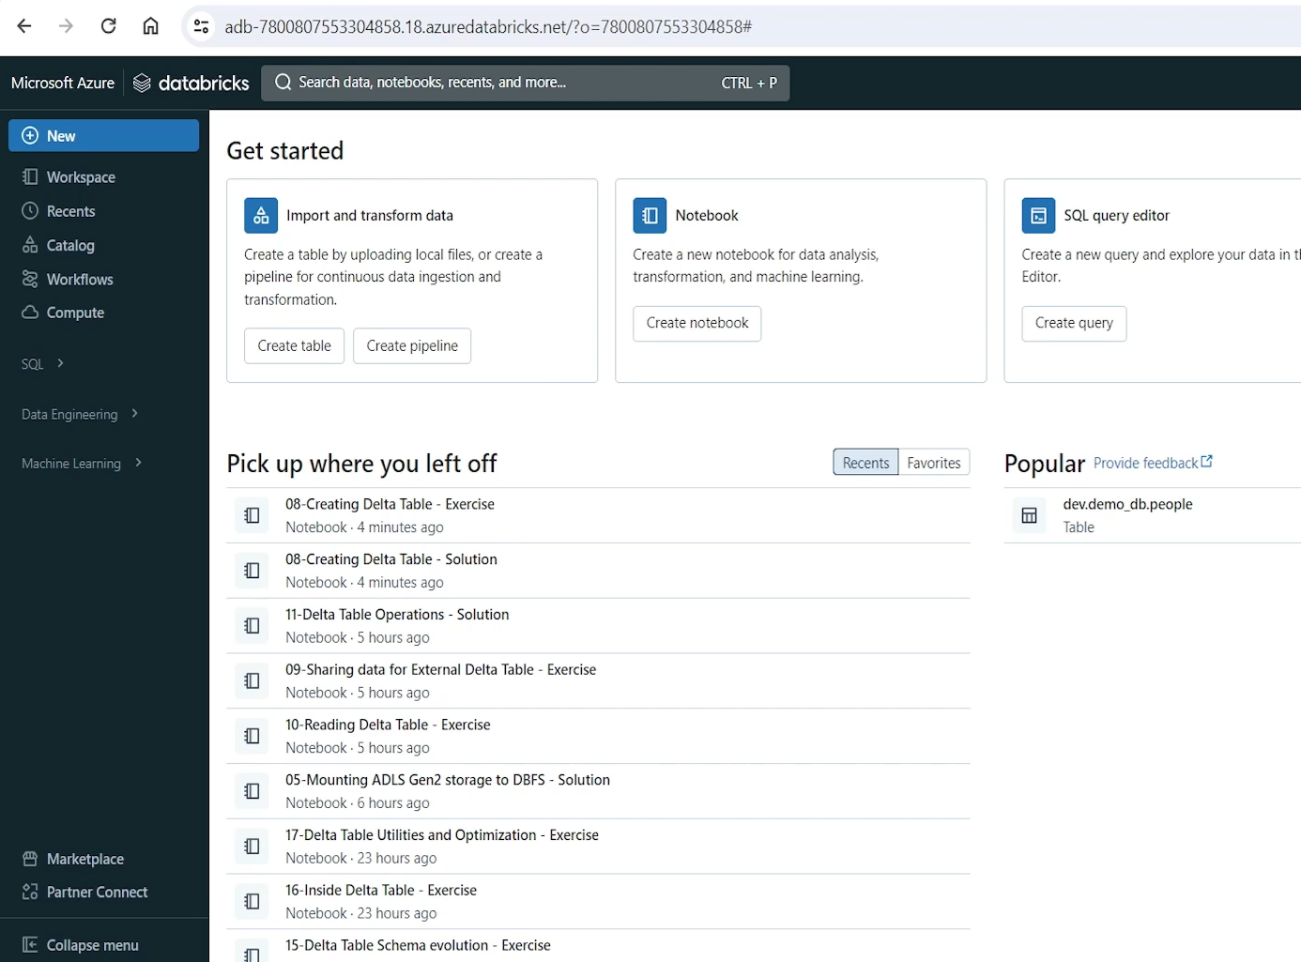

We will learn to create Delta tables. If you already learned in spark, possibly you already learned how to create delta tables. But in this lecture let's formally see how many ways we can create Delta table and learn some commonly used approaches for creating delta table. So let's start. Let me go to my Databricks workspace and in my home directory, I have set up a notebook to give you a demo on this. Let me attach a cluster so I can run my notebook, as usual with all our notebooks, we have first line, for doing the cleanup. So let me run the cleanup code. So if there are any experiments or something I have set up, we are able to clean that up. And we have a clean environment to start our learning. Then we have a setup step. for this step, we will be setting up few things for exercises in the same notebook. So here is the setup code for, this notebook or for this chapter, you can run this setup, but before running the setup, ensure you have dataset_ch7 setup at the mount point. So in the earlier lectures we already mounted this location.

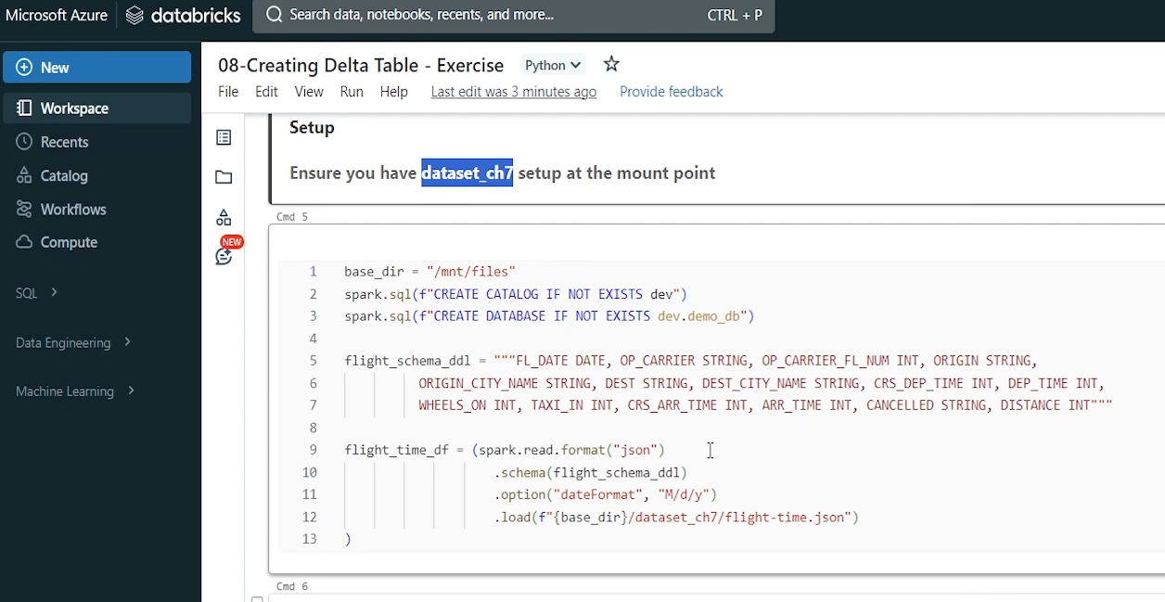

So we want to use that mounted location. For, our raw data access or for course data. So make sure that you download this chapter data or download this folder from your project resources or from your course resources, and upload it at the mount point before executing this setup. So let me do that. I'll go to my storage account in the Azure cloud. Come to containers. And this is the container that we created in earlier lecture. We already mounted it in this workspace in the earlier lecture. And now let me upload the chapter seven data set here.

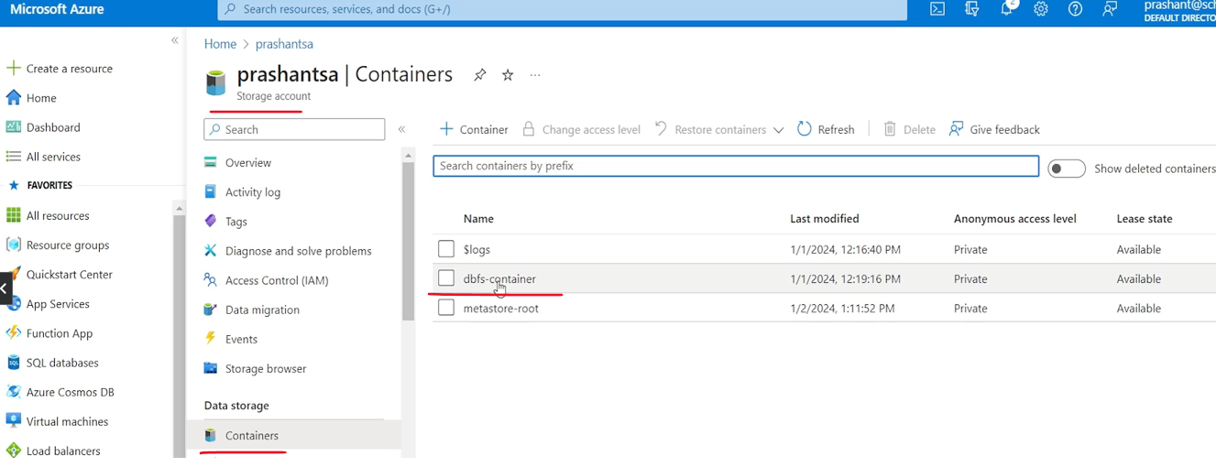

So I'll simply drag and drop it here and hit the upload button and once upload is done, we will see a success message. Okay, so I have dataset_ch7. I downloaded it from, course resources and uploaded that in in the Dbfs container, which is mounted as mnt files in my Databricks workspace. And I have three sample data files, which we will be using for this chapter. So now we are ready to run this setup.

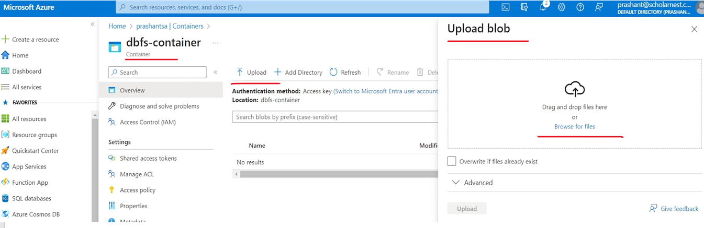

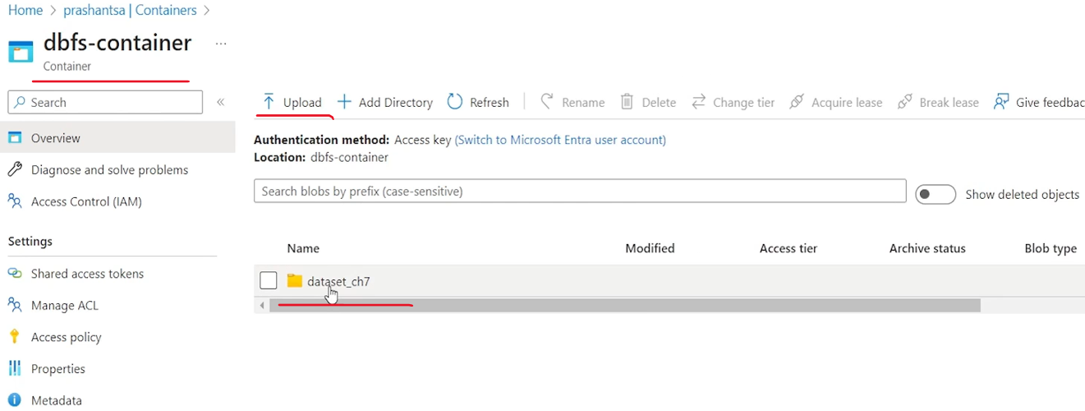

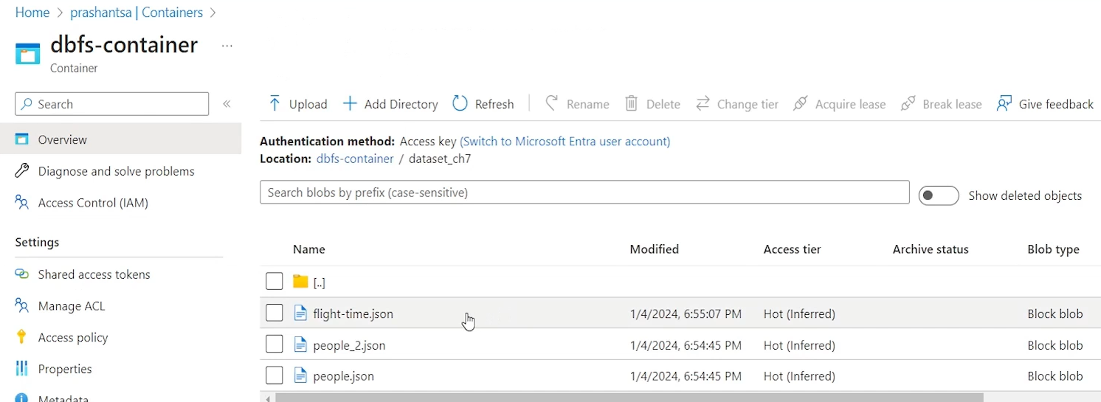

So let me execute this setup. Hopefully it will run without any error.

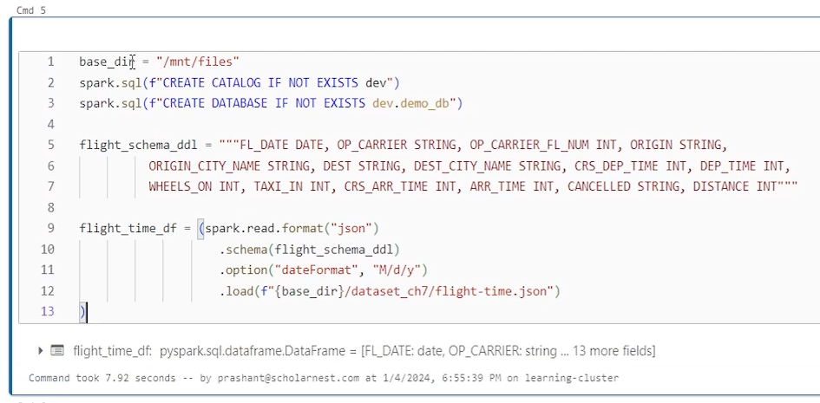

So what we are doing in this setup are simple things. I have defined a variable based dir at mnt files. I am creating a catalog dev catalog. Then I'm creating a database in the dev catalog. Then I have this schema for flight time data set. And all I am doing is creating a data frame, reading data from Json format file with this schema where date format is this, and I'm loading it from the the mounted directory, which is my base directory, dataset_ch7. And this is the file name that I am loading. And that's why if you are following along, it is necessary to upload this data set, in your mounted directory. So don't forget to do that. So now we are ready with the setup. we wanted to learn how to create delta tables. That's what we wanted to learn in this lecture.

|  |  |
| --- | --- |
|  | So there are many ways to create delta table. But but in particular we use three approaches I will explain you three approaches. The first approach is super simple. Use create table DDL statement and you can create delta table. So let me show you an example here I'll simply type the create table DDL statement here.  My notebook is a Python notebook, so maybe I'll have to change the cell language to, SQL and create. Table, let's say if not exist. And then I want to create this table in the. Demo DB. Database which is in dev catalog. So dev catalog dot demo db dot table name. let's call it. Flight time table. And then we define a parenthesis. And inside that parentheses we can define our column names. So let's say FL date is the first column name. What is the data type. Let's say it is date. And then I can define a list of all the columns.  And this is how it looks. Right. So this is a create table DDL statement create table if not exist table name is this all these column names and their data types I defined it. what type of table it will be. Will it be delta table or it will be a parquet table. Or it's going to be a Json table in Databricks. |

|  |  |
| --- | --- |
|  | Default file format is delta. So this will become a delta table. What it means the data created for this table will be stored in delta table format. Alternatively you can write using and specify delta here. And that's all. If you use using delta at the end you are making sure that it is delta table. Otherwise it this this is default in Databricks.  So it's not mandatory. If you wanted to create a parquet file or Json file maybe you can. Call it Json using Json, and then you are specifying store my data for this table in Json file format. But we wanted to make sure it is delta. So that's how we can create a delta table. Let me run it and make sure it is created. Okay. So table is created. So this is one approach how you can create delta tables. |

What is the second approach. Second approach is to use your data frame APIs. So let me show you a simple. Let's look at this code.

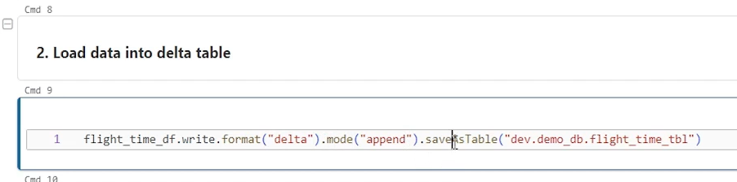

Hover on the df and you see this

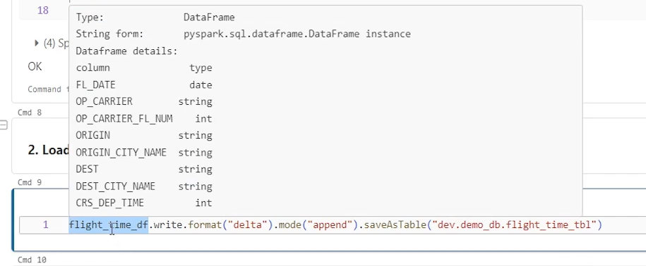

This is a data frame flight time DF which I have defined here by loading my sample data from the flight_time.json file. on that flight time df I'm using right? And format is delta. That's all mode. I'm using append mode and writing it as save as table and save as table is a powerful method in the data frame. What it does, it will look for the table. If the table already exists, it will load data into the table means it will save data into the table. If table does not already exist, it will create the table and then save the data into the table. So for creating new table what it will do it will look at the format and format is delta. So it will create a delta table.

So this approach is also an approach for creating delta table using an existing data frame. But when you create use this approach for creating a delta table, you are not defining a schema explicitly for this data frame. or for this table, schema is taken from the data frame schema. All the column names and data types, all the definition for the schema is taken from the data frame. And this table will be created with that schema. But if table already exist, then we will simply load the data frame data into the table. So let me run this for this example it will simply load data into the delta table. So we are loading data into the delta table table we already created using DDL. And this is preferred approach. Use DDL for creating delta tables. And then maybe you can load data into those tables. Later idea is to make sure that you are creating delta table with a well defined schema as you desired.

If you use data frame to create a new delta table, it might be possible that you didn't look at the data frame schema. And by mistake, or for some reason, you created a delta table using the data frame and you didn't create a table with the desired, data types, desired column types. So to avoid those things, we always write a setup script for our projects to create all the desired tables. So that's how you can, create delta table or load data into the table. Once data is there in the table, maybe you can simply query the table.

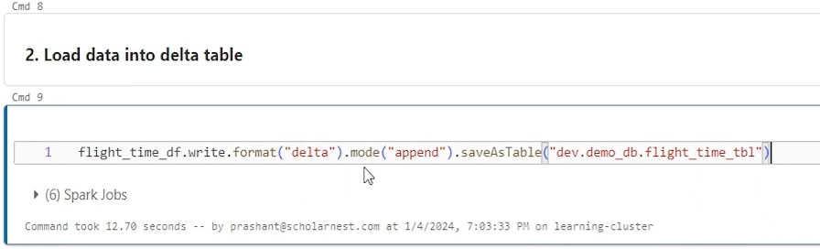

And you should be able to see the data. So here it is. The query is running. We loaded data. So. I can see the data here.

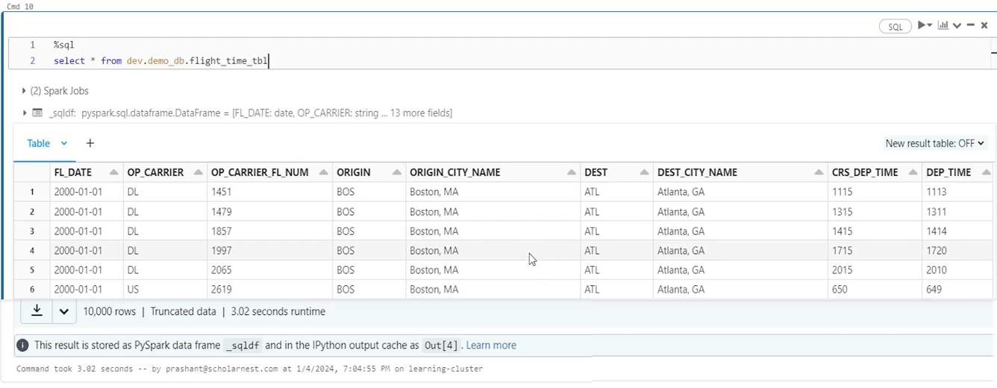

|  |  |
| --- | --- |
|  | There is one more approach for creating delta table. that is called Delta table API or Delta Lake APIs. We don't use that approach very often, but we have another set of APIs, Python APIs for creating delta tables. We call them Delta Table Builder API. So let me show you how to use it. We have to import the delta table object.  So let me do it from Delta. Import delta table. And this is the object which we can use to create our delta tables using, Delta Lake APIs or Delta Table Builder APIs. So let me put a parenthesis here. I'll write my code inside this. And we start with the delta table and then dot and then maybe You have create or replace method. And this method takes a spark session, as a parameter. And then the create or replace is for create or replace table. So because this is a table builder API it is a delta table. Create or replace means it is going to create or replace a table. And then in the next step you can give table name. And in this method you pass the table name. What is the table name.  We can use something like this. Your catalog name, dot database name, dot table name. And once you define the table name, then you can start using add column to define your table structure. So first method in the first parameter in the add column is like your column name. And second one. Second one is, data type date. You defined one column, then? Come and define another column like that, we will define all the columns. So for simplicity, let's copy the code. So that's how you define your, Delta Table Builder API for creating a new delta table? |

That's another approach. We don't use it too often, but you have an alternative. Once you are done defining all these, columns, maybe you can use, Execute method to run this. So if I run this, what will happen? Delta Table Builder API will. Create or replace this table. We already had a table, but now I'm running Create or Replace so it will replace the existing table. Earlier we had data in that table. So select statement returns some value. But now I did a create or replace. So data should be lost. And let me see, no records, but table does exist right.

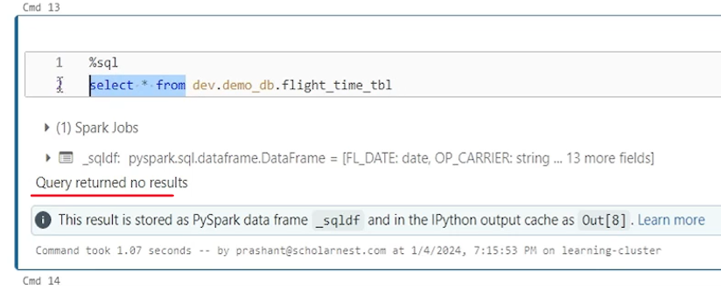

You you can describe this. Our table and you will see that table does exist.

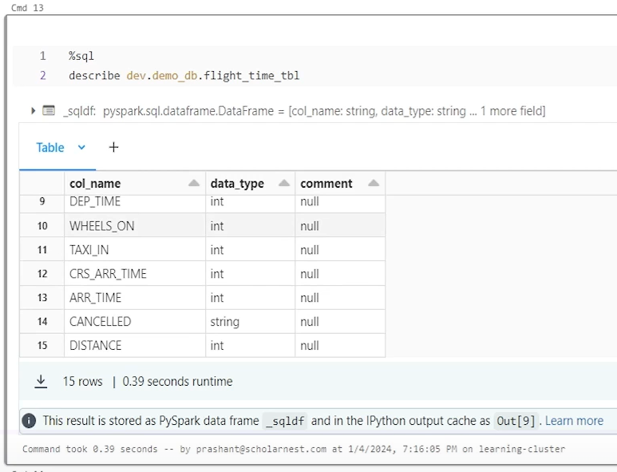

### Sharing Data for External Delta Table

we will learn to share delta table data in an external location with other teams. So let's start. Let me go to my workspace. And in my home directory. I have set up a notebook for this exercise. So as usual, let's connect a running cluster so I can execute code in this notebook. Let's do the cleanup. So we set up a clean environment for this demo. So clean up is done. Let's do some setup. Basically, I'm creating a catalog, a database and creating a data frame. Now we are ready to create an external location and share data in delta format at an external location, so other teams, teams may be outside. Your project could access that data from an external location. So how to do it? There are two parts of it.

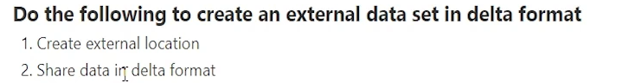

First, create an external location and then save your data frame as a delta table or in delta file format at the external location. So let's start, uh, performing both these steps. The first step is to create an external location. And as we know, creating an external location requires an credential. So you can go to your catalog Explorer and look, if we already have some credentials. So come to external data tab and storage credential I already have a storage credential. Basically this is the storage credential that is automatically created when we created the Databricks Access Connector.

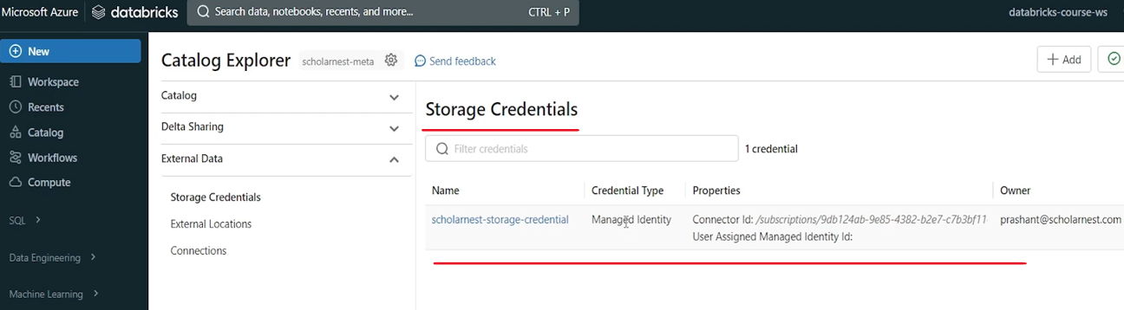

And this is the name for the storage credential. usually when you create a connector, this name is automatically created. you might see a weird name which is automatically generated by the unity catalog. So you can change the name as you need. So you, you have a rename functionality here where you can change the name. So the idea is to give credential, an appropriate name which you can memorize or which you can remember.

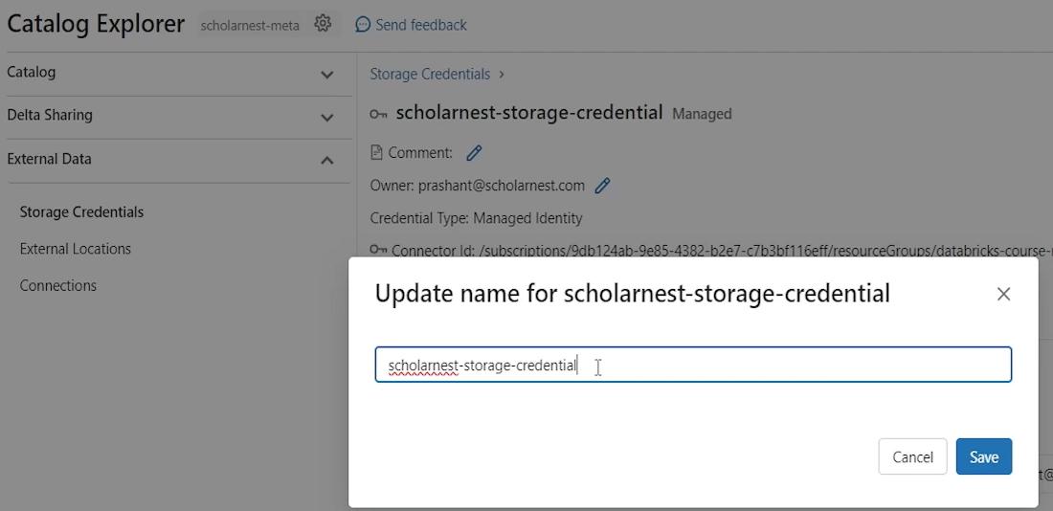

So this is the name that I already, gave to my, storage credential. this is the storage credential. Scholar stores storage credential. We will use this storage credential to create an external location. We already learned that we can create external location using Catalog Explorer UI from this button in the earlier lecture, but now we want to take it as an opportunity to learn how to create external location using code. So let's come here and write code to create external location. How do we create an external location? Simple. It's a kind of DDL statement. Let me change the cell type to SQL. And then create external location. For safety. You can use if not exists and then give a name to your external location. Let's call it external data. So that's the external location we want to create. But for creating an external location, you have to supply two more things. What is the URL for your external location and what is the storage credential you want to use for that external location. So let's give the URL a URL and in your URL should go in a.

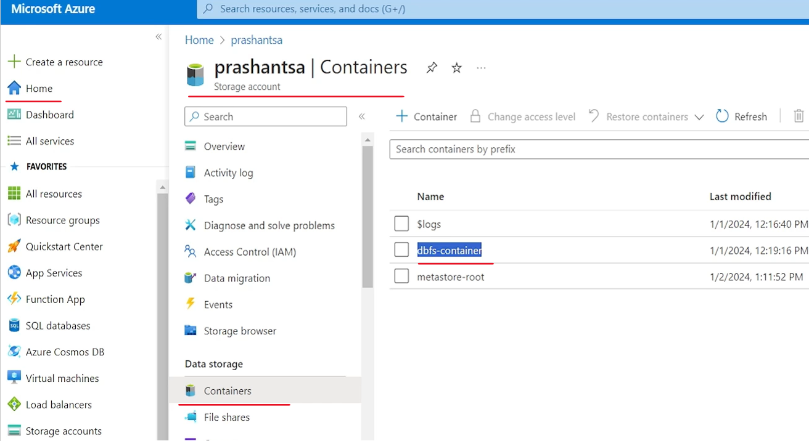

A single quote or double quote as a string. But what is the URL? URL should be created in the format of File. Qualifier. So we want to create external location in the Azure cloud. so this is the qualifier for Azure Cloud. So abfs:// and then we specify the complete URL for the external location which is in the format of container name @ storage account name. So what is the container name. Let's go to my Azure portal and see what, Container do I already have? So I'll come to my storage account and look for containers. And in earlier lectures I already created this container. So let's create an external location in this container itself. And so we come back and tell the container name at the rate storage account name. What is the storage account name. This is the storage account name. So we use container name.

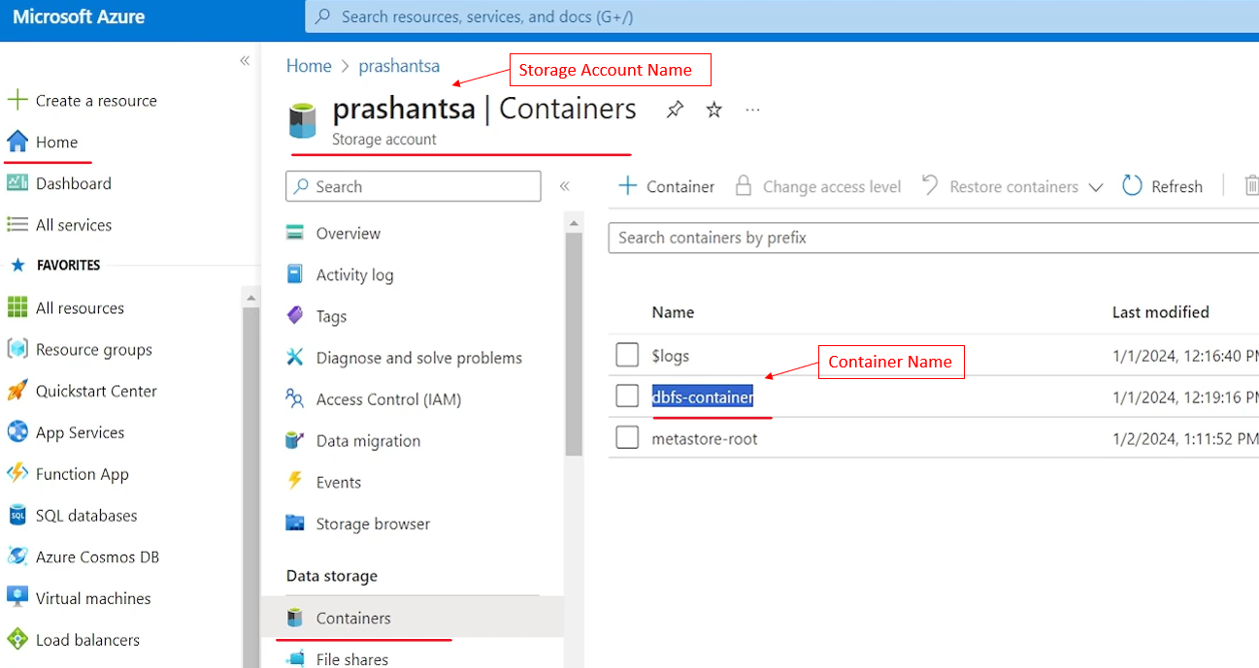

Add the storage account name and then. We supply the Azure storage account. rest of the URL, which is like DFS dot core, dot windows dot net. So that's the URL. And we go to root directory which is like this container. So I can use the entire container for creating an external location. Or maybe we can ask for a directory in the container. So we create an external data external location which points to the external directory in this container in my storage account. So that's how we can give the external location.

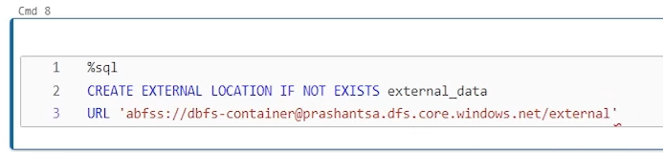

And then we need to supply the storage credentials. So how to give the storage credentials so we can use with storage credentials URL. storage is optional. So you can simply use With credential, and here you can give the credential name in a pair of backticks. So a pair of backticks. And what is the credential name, we created a credential here. which is already there.

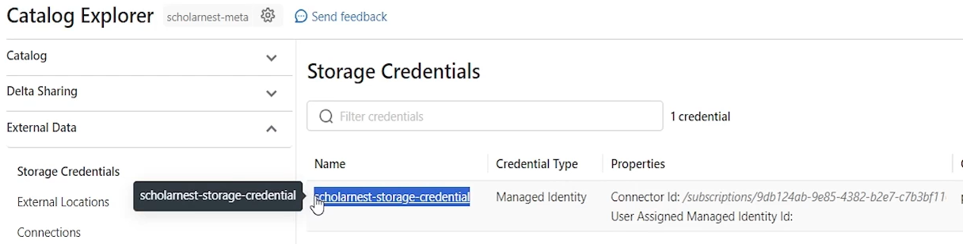

So I use this credential name and that's all. That's the DDL statement for creating an external location. So let me try running it. Okay, so it looks like it worked, and if it worked correctly.

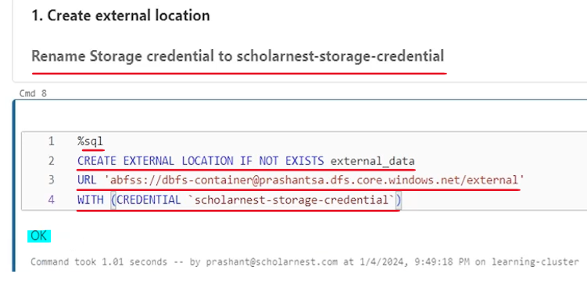

I should be able to access this URL using maybe percent FS. So let me do an LZ. But we also need to make sure that this directory already exists in my, container. So let's go there. Look inside the container. there is no directory for, external.

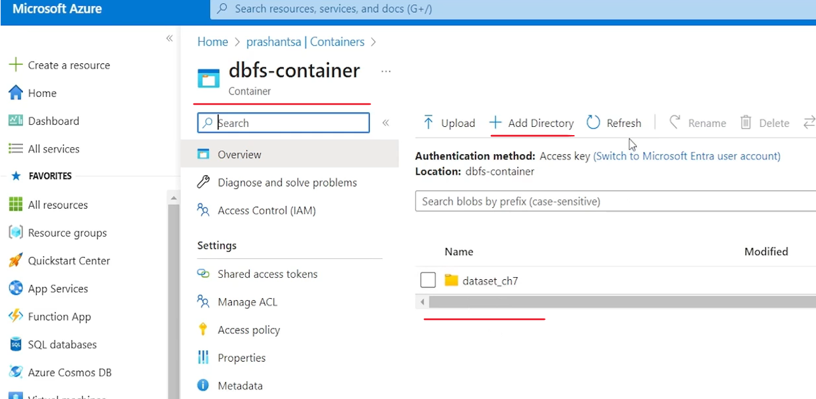

So maybe let me create a directory name here. This is the directory name that we want to use. So. This directory is there now. Let's try to. Access it. It works. Nothing is there.

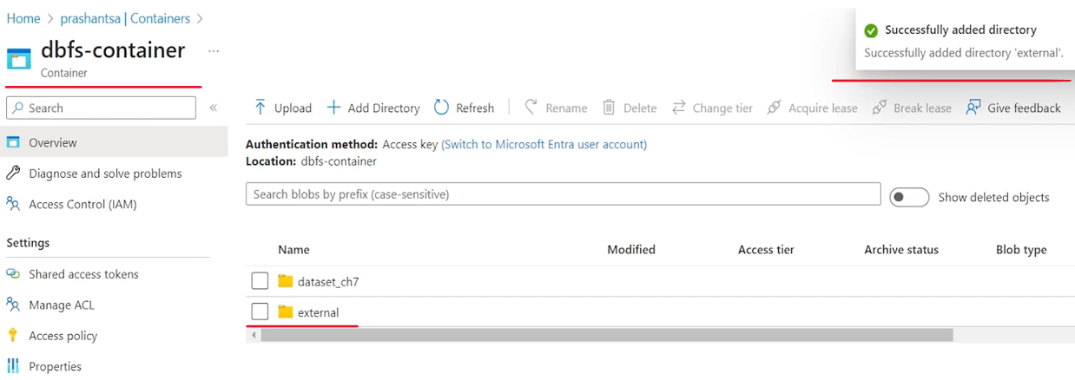

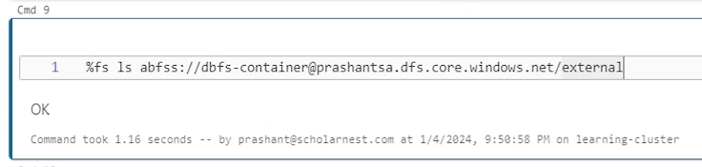

And that's obvious because we just created the directory. There is no file in it. So we successfully created the external location. Now what do we want to do next. We want to. Write our data frame so that we can share data in the external location at the external location for other teams. Other teams can read it from there. So I already have a data frame here. Let me try to save that data at the external location. So I'll try to write my code inside the pair of parentheses and data frame. How do you write that data frame df.write and then maybe format. We want to make sure we are writing data in delta format. So format is delta. And then maybe mode we can give is Overwrite mode and. Save it. Right. And, for saving, I have to supply the location. And what is the location? Location is this URL at which we created the external, location. So we cannot use the external location name. I have to use the. URL, so let's use the URL here it's like this. And that should be all to save the data. But I know that when I save a data frame to a location, it will create a number of files. And those n number of files are always equal to the number of partitions in this data frame. So I don't want to unnecessarily create too many files in that, external location. I know this is a small data set, so maybe, before the right. Before the right. I can use coalesce method and try to coalesce it to a single partition. Coalesce is efficient. It doesn't go for shuffle, so I can easily coalesce.

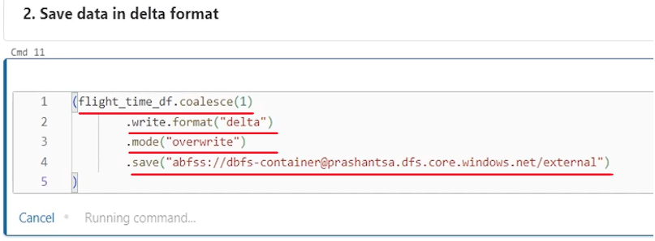

And now let's run it and see if we. It works. So it's writing the data at the external location. once it is written, I should be able to access it. So let's prepare for it. And let's verify.

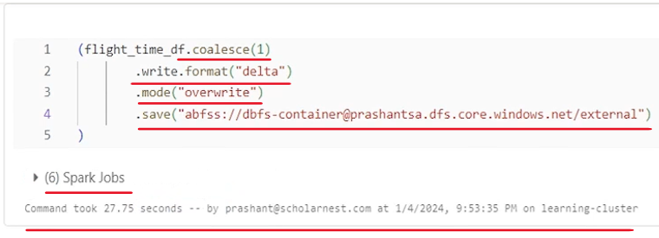

Once this is done, I can verify. It's done. Let's verify what we created at this location. So. It's done. We see delta file is or delta format data is created at the external location. And delta format data is created in two parts. The part one is the data. So we see the actual data is stored as a parquet file. So delta table or delta format behind the scene is stores data in the parquet format. Parquet file format. So this is your data but it is delta table. So delta table or delta format data will also create a underscore delta log directory. And inside the directory it will store the transaction details.

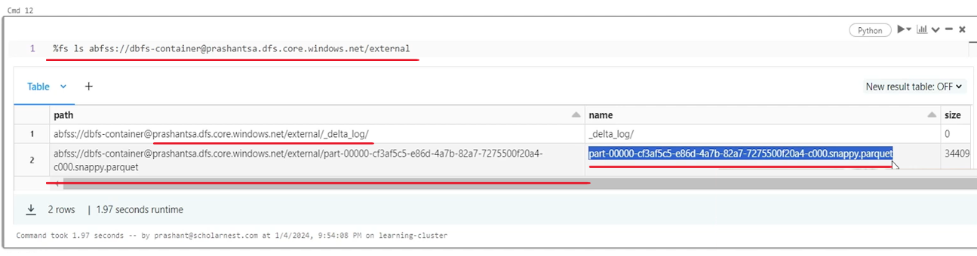

So we will investigate what is there inside the delta log in a later lecture. But for now we wanted to create a external location and share our data at the external location. So other teams can access it from the cloud directory or from the cloud, storage container. So we are done with that.

### Reading Delta Tables

we want to learn how to read delta tables. So let's get started. let me go to my workspace in home directory. I have set up a notebook for you. reading Delta table. As usual. connect the notebook with the cluster. Run the cleanup script. And then run the setup script. we are setting some data set for being able to work with it. So basically I'm creating a delta table. Delta table is. Dev demo DB dot flight time table. So how do we read Delta table in spark? Using spark SQL. No brainer. Simple. Use spark SQL.

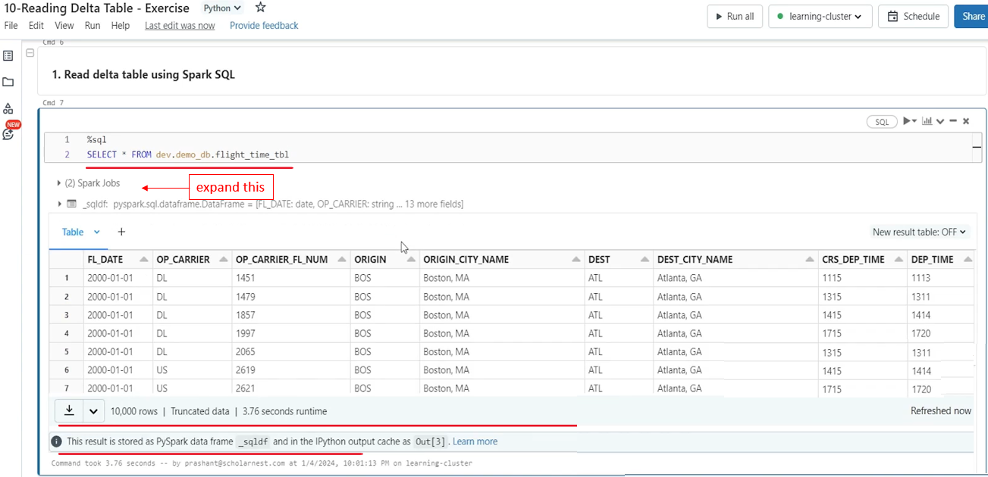

Select * table name and you can use or read the Delta table. You already learned that you have been doing it for a long time in a spark now, so that's simple. but how do we read Delta table using data frame API? That's another approach for reading Delta table. No brainer. Again. So we can start with this spark and use the read and maybe tell the format and format is delta. This is optional in Databricks because in Databricks default format is delta. So even if you don't tell format, this code will assume that you are trying to read a delta format data set. And since we want to read a table, so we use maybe table method. And in the table method we can give the table name. What is the table that we created. We created this table. So that's your delta table. Give the table name and once you are able to read it will return the data frame. Maybe you want to display it. So let's add a display and you can read the. Delta table as usual using the data frame API. So both the methods are simple, easy, straightforward.

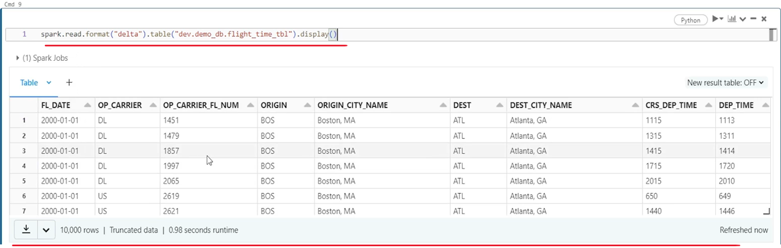

|  |  |
| --- | --- |
| But let's assume that somebody or some other team has shared a Delta data set with you at an external location. Some other project has shared that, and you want to read that data in your spark code.  How do you read that? So again there are two parts of it. First, you should create an external location and should have access to the external location. And then you can simply read a delta table or delta format data from the external location. |  |
| So let's try to do that. We already learned how to create a external location in an earlier lecture, so I'll simply copy that code. I'm not going to explain that once again. so here is the code for creating an external location, data is assumed to be available at the external, directory in this container, in this storage account. And using this credential, we have access to this location. So let's create a external location. External location name is external data. So we created a external location. |  |

Now if you want to read it using Data Frame Reader API, you can read it how you already know that how to read data from a directory location using data frame reader. So. Let me write code for that. How do you do it? Spark dot read and you can tell format which is optional. If you don't tell the format, it is assumed to be Delta, and once you tell the format after that, you can. Load it, load it from the location. And what is the location? We know data is available at this location, so instead of using. External location name, you can directly use the URL, paste that URL and this will work. This will work because we already have an external location setup. if you don't have an external location setup, this is not going to work. But since we have already have an external location setup, we defined how to access this location using this credential. So. A spark will be able to read it behind the scene. Unity catalog will provide access to this location using this credential. So once you load it, maybe you want to display it. So that's all. That's how you can read. Um. Delta format data from a directory, so let's run it.

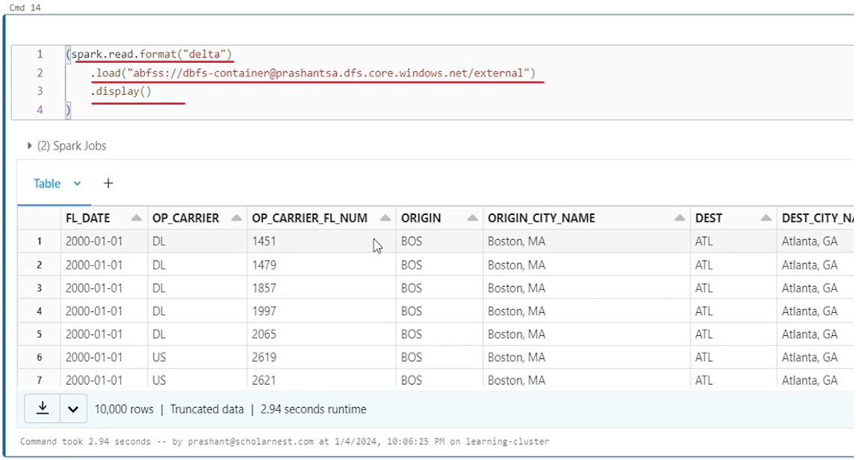

And it works. But usually when we get data at an external location in a project, we would want to create an external table on that data. we have data which is delta format data at this location, but we want to create an external table on that. how to do that?

|  |  |
| --- | --- |
| How to create an external table. You already know that in spark you can create an external table, the syntax is same.  You have to use, create table DDL, with location. And as soon as you give location, spark assumes that it is an external table. So let's do that. Create table, maybe for safety you can use, if not exist and then give the table name. So let's create this external table in the dev catalog in the demo-db database.  And let's give a table name. Let's call it flight-time-ext-tbl external table and then in the pair of parentheses, you can define the schema for the external table. for example fl_underscore-date column which is of date type. And then you can define rest of the columns. instead of typing it I will simply copy paste it to save some time. |  |

So this is how you create a create table DDL. But we know that this table that we are creating from the external location, is a delta table. It's the data is coming as a delta format data. So we can use using Delta command. So. Make sure it the DDL knows it is a delta table. And then since we are creating an external table. So we must give the location. And what is the location? Location is the same external table URL. Right? This is the location. This is where data is. And this location will work because we have created an external location for that. So let's paste the external location here and create the table. So external table is created, maybe you can test it selecting data from that table. So we can access that data as a table. And since it is an external table, we know in spark, if you drop the external table, spark will remove the metadata.

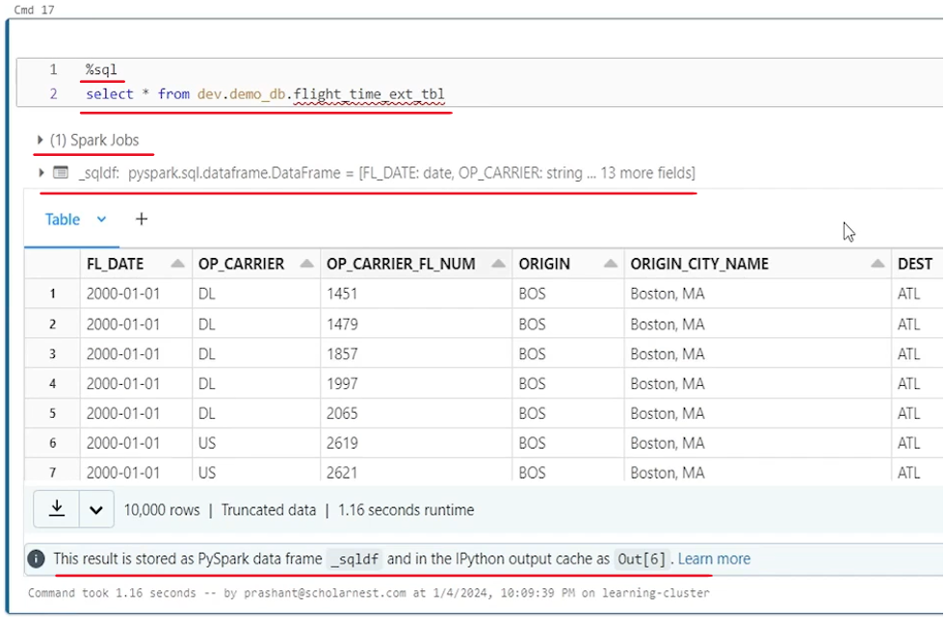

Only the external table metadata will be removed, but a spark will leave this location untouched. And that makes sense also because that's the external location data is shared by some other team.



We want to read it, but we don't want to drop that data. We don't want to delete that data. So that's why we created a external table. We are accessing it. And at the end we may want to drop this external table which will drop the table metadata table. External table will not exist but data will remain as it is. So we'll leave the data at the original location where it was for other team to do whatever they want to do with that data. And that's all for this lecture. We will meet again in the next lecture, learn a few new techniques or few new things to work with the delta format data or delta table.

### Delta Table Operations

We will learn to implement delta table specific operations. Delta table brings three unique operations to Apache Spark. One is deleting data from the Delta table, updating data from the delta table and merge statement. So how do we implement these. We want to learn it with an example. So let's start. As usual, I'll go to my workspace and I've set up a notebook for you. To give a demo on the delta table operations. let's attach a cluster. Run the cleanup. And once clean up is done, do some setup. So we have one delta table to work with.

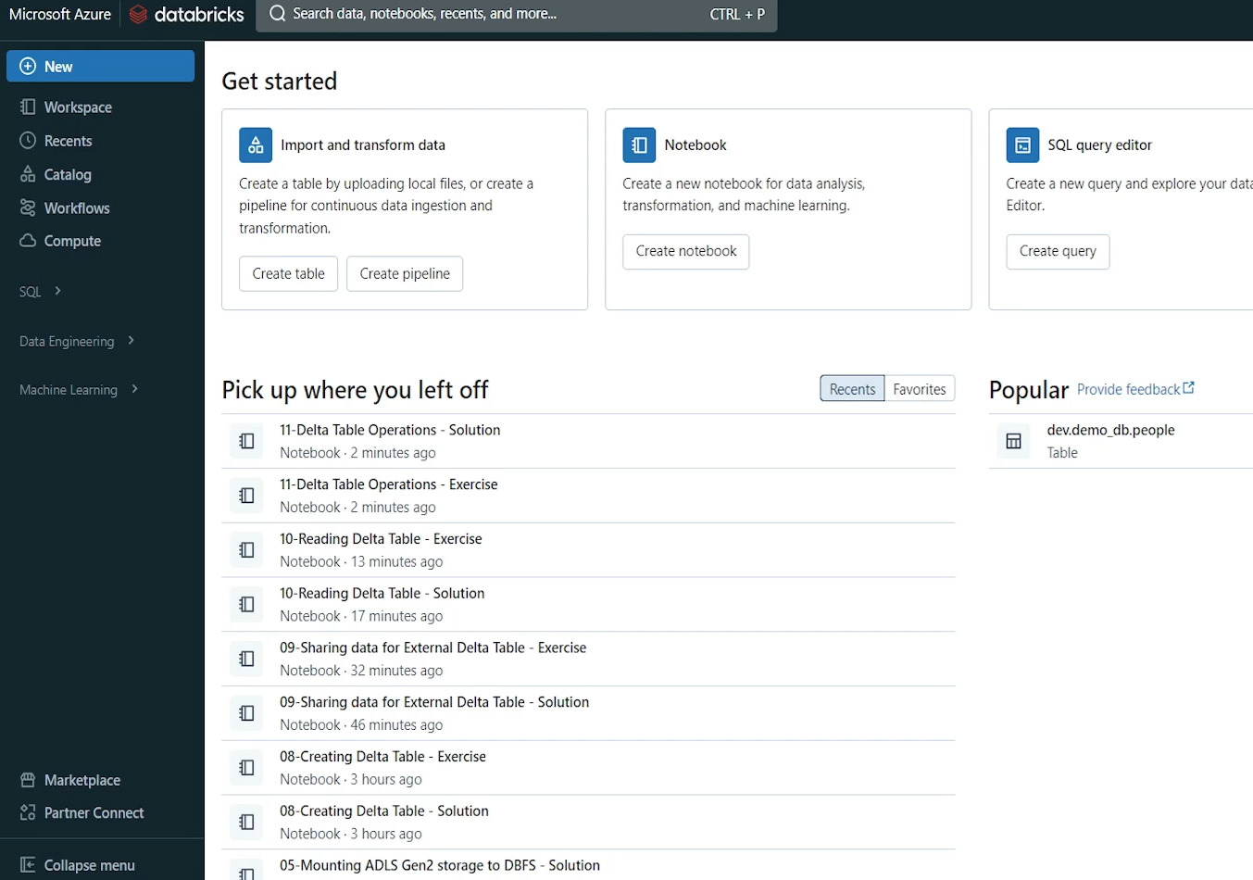

Basically we want to learn how to delete, how to update and how to merge. So once this is done we will start.

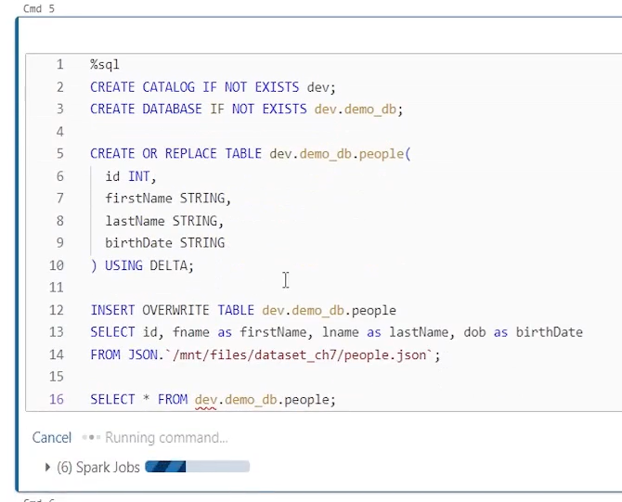

So I have this delta table dev.demodb.people. We want to learn how to delete some records from this table using spark SQL. So let's do it. You know delete syntax in ANSI SQL. So same syntax works here. How do we do it. Delete maybe from and then give the table name. Don't forget to give some condition. So you delete only what you want to delete. So let's say first name equal to. M. David, I think M is capital, so we can write simple delete expressions in spark SQL to do the delete from the delta table and delta table supports delete operations and one row deleted.

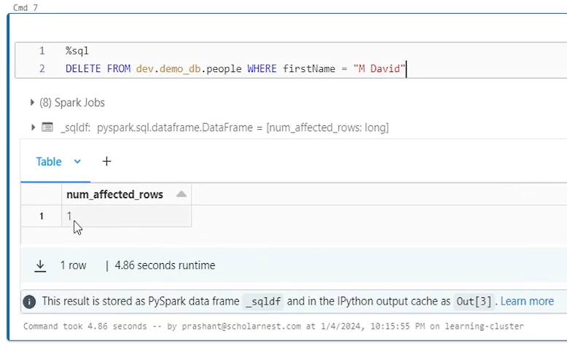

So it's as simple. Similarly you can use any SQL syntax to update. Delta table or to merge, one source data set into a target delta table. You can do all that using spark SQL or ANSI SQL. I'm assuming that you already learned spark SQL and you are familiar with the SQL syntax. So I'm not going to give you a demo for, update and merge statements in spark SQL. you assume I'm assuming that you already know that. But one thing I want to highlight here is that delta table operations like delete, update, and merge are not available to using data frame APIs. Spark data frame APIs do not have a methods or approach to update, delete, or merge data into the delta table. So you cannot do it in Python. You can do it in spark SQL, but we have another approach for doing it in Python. So if at all you have a requirement where you want to implement delete statement or update statement or merge statement using Python code, you don't want to use spark SQL for that. You can do it using Delta table APIs. So how to do that? Let's try to learn how to delete one record from the delta table using Delta table API. We deleted one record using spark SQL, but how to do it in Python. So for doing that you have to import from Delta. You have to import. Delta table and Delta table allows you to read delta format data or delta table and create a delta table object. And once you have the delta table object, you can implement, delete, update and merge on the delta table object. So let's create a people_dt, this is going to be my delta table object, and I want to use Delta table API for reading delta format data. It's not data frame API, right. And delta table gives me one method call from name. So this method allows us to read a delta table using the delta table name. The first argument for this method is a spark session. We have to tell which spark session to use, and then we have to tell which delta table what is the delta table name. So we want to read the same delta table that we used earlier. So let's give delta table name here. And this method will return a delta table object. It's not a data frame object. It's a delta table object. So now we have a delta table object.

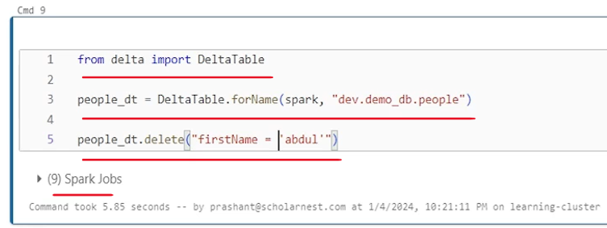

And using the delta table object I can implement delete. So let's do that. So you have a people dot delta table object. And then on that object you can use. Delete method and delete method. takes the where condition. So for deleting if you don't give where condition the entire table is deleted. So let's give a where condition. Maybe first name. Equal to, uh. A literal. Abdul. And that's all. That's how you can write a delete statement on delta table using Python. We already know how to do it using spark SQL, but sometimes you may want to do it using Python. So this is the code. Sorry. It's not from name. It's, uh. For name. So. Let's try again. And it worked. behind the scene, we deleted a record which has a first name equal to Abdul. how do we do update using Delta Table API? Again, if you have a delta table object like people-dt and you want to do an update, you can use update method. And update method takes condition and set to parameters. So let's define some condition here. Condition equal to and in double quotes you can give the condition statement. So let me copy a simple condition here. So we want to update all the records where birth date equal to this. And then next parameter is set, set means what values do we want to set. for this update. And that set you can give in. A pair of curly braces where each field you can define with the comma separated values. So let's say uh. Set the first name. Two. Uh. Maybe. What do we want to do? Let me import pyspark.sql.functions as f. And what I want to do f.initcap. So I want to use initcap function to first name itself. so what do we want to do? We want to set the first name with the initcap of the first name. That's one thing we want to do. We want to set one more thing. And that should be let's do. Last name. Last name equal to maybe something similar. In it cap of lastname. Simple as that.

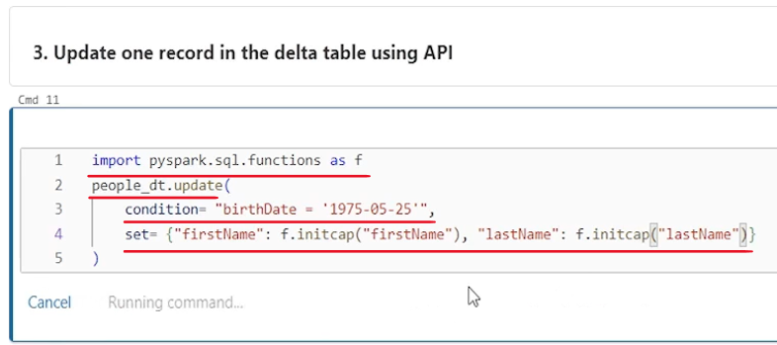

You can use update statement like this if you want to do it in Python, or you can use spark SQL. functions has no attribute in it. Cap. Sorry. It's initcap. That's all you are done with the update are. Similarly, if you want to do the merge using delta table API, you can do the merge. Also, we are assuming that you already know how to do the merge statement using SQL. It's pretty straightforward. So for merging, let's assume your delta table is target. You need some source. And from the source you will match records in the target. And when matched you want to take an action. If it is matched, do some update. When not matched insert or when matched, delete all that you can do with the merge statement. So let's create one source data frame first and then we can try merge statement. So this is the source data frame I want to create a source df read reading a Json format data from this mounted location. I have already mounted this location and this data set is already available at that mount point. So this is the source data set and we want to match it in the target table. My table is like this people_dt I've already created a data delta table object on the people. If you want to show it, you can convert it to, to DF and then display. So let me display it once so we know what is there in the target. So we have two records in the target. We have four records in the source 101104101104 should match. And if they match we will update some values here. And 102 and 103 will not match. And if they are not matching we want to insert them.

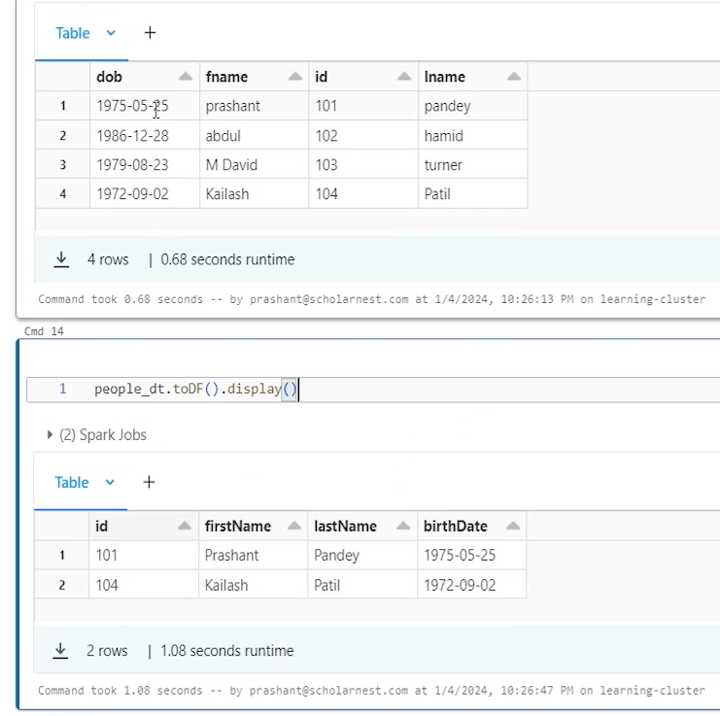

There are few more differences - in the source column name is id and target. Also column name is ID in the source column name is f name and in the target column name is first name and here it's fname. Here it's last name. We have DOB here and here we have birth date. So column names are different. So basically what we want to do we want to write a merge statement using Delta table API and merge this data into this table. So how to do it. We definitely start with the people_dt which is my delta table object. And then maybe give an alias to this, let's call it, tgt, which is target. And once we defined an alias for this, we can use merge method on the delta table and merge method takes what is the source, and source is, this data frame that we created, right? So we pass the source here. But we want to give an alias to the source also, and let's call it src. So that's my source for the merge. And then I need to give what is the join condition? On what basis we want to, match the records from source to target. So we want to match it on the ID. So let me paste the condition here. It's very simple condition. The source.id equal to target.id. That's my, matching condition. Once we matched it, then we need to take action. And action could be when matched or when not matched. So let's start with the - when matched in when matched, you can do delete or you can do update, right? So let's do an update when matched then update. So we have a method for that when matched update method. And this method also takes condition. And, set.

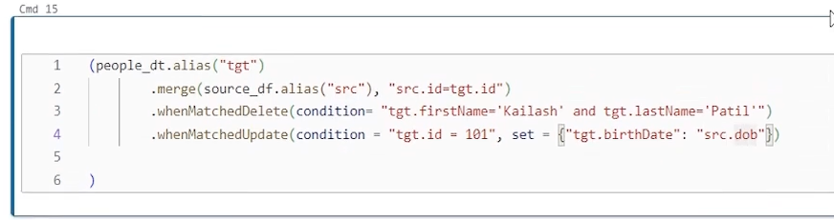

It's similar to the update statement that we learned here, condition and set, or you can do when matched delete also. So let's say when matched delete. So let's say when match delete and we want to do when matched update also. So when matched delete and we want to give some additional condition. It's not like that when matched delete. So we don't want to delete everything which is matched. We want to see when records are matched. We want to give some additional condition. If that condition also true then only delete it. So you can give that condition here in the when matched delete and condition can go in a as a string. So let me put a simple condition here. let's say we want to delete when records are matched and target first name is Kailash and target last name is Patil. So this is my target data set. So basically. If 104 is here, which is there if 104 matches with the 104. And first name is Kailash and last name is Patil. Then delete this record. So we want to delete that. Next we want to update. So when matched we want to update. But we don't want to update all the matching records. Maybe we want to give another condition. So let's put a condition here. Equal to and condition goes in a parenthesis. So let me copy a simple condition here. And. It's like this. So when matched and target is target ID is 101, I mean this record then what we want to do, we want to update. And for update we can give the set.

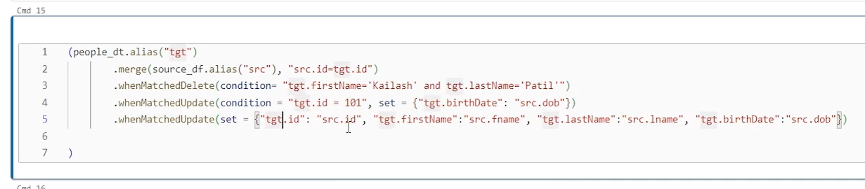

And what do we want to set. Let me copy that. Set goes in a pair of, curly braces. Like we learn the set statement in the update method. Same way we have to give the set here. So what we want to set a target birth date should be equal to source dot dob. So if record matches and the id is 101 then this birth date should be updated with the this birth date. Right. So that's how we want to give an when matched update. you can also have an unconditional when matched update at the end. so let's add an unconditional when matched update at the end. So what it will do we have three one matched. So when matched we want to delete but with an additional condition. If this condition is not satisfied, don't delete it. Look for the next operation when matched update with an additional condition. So if this condition is true, do this update. If this is also not satisfied, then come and update all the records unconditionally.

And what do we want to do in the update? we want to set a lot of columns. So let me paste here. I don't want to give condition to this. We simply give only set what we want to set target ID equal to source ID target first name equal to source f name target last name equal to source l. Name target birth date equal to source DOB. That's what we want to update. And finally maybe when. Not matched. insert. Right. I want to insert. And which fields do we want to insert? So. Insert method takes a values argument. values and values also go same way the set. Goes for update. So let me copy something here and then I'll explain. So here it is. So values is targetted equal to source.id first name equal to f. Name targets last name equal to l. Name birth date equal to DOB. So we want to insert, all the values from the source to the target. That's what we want to do. And once all is done, maybe at the end you can use. Execute. That's mandatory. So we do the execute. So this code will implement all this. That's how we can implement merge statement in delta tables using delta table API. That's the Python approach. Otherwise we have a spark SQL which is an easy approach. So let me run this. Let's see if it runs.

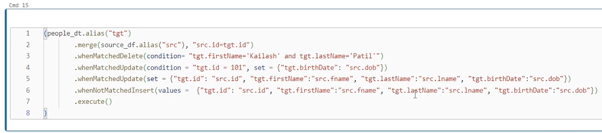

It worked. And we were trying to merge into this delta table. Right. So what is the delta table? Let's query that. We created the delta table and the beginning. This is the delta table which is my target. So let's. Query it and see what is the status after the merge. So after merge we have four records. Before merge we had three records, but 104 we wanted to delete. Kailash Patil so this is gone. 101 is still there. maybe date of birth is updated and 102 and 103. these two records were there in the source, which were new records.

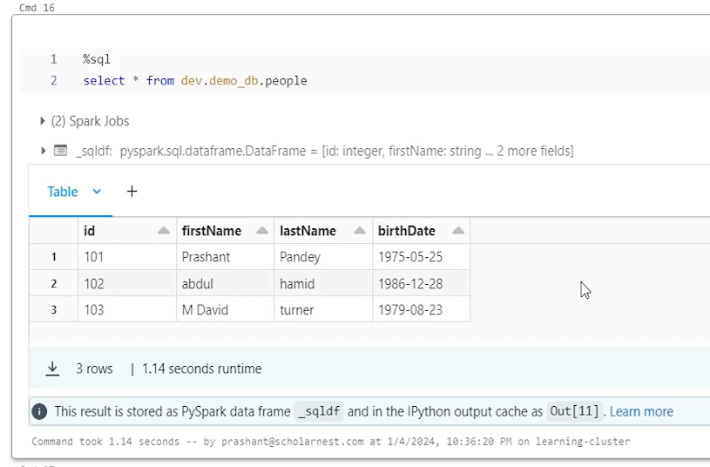

So they were not matched and hence they were inserted. So looks like it worked correctly. that's all that's all about this lecture. We will catch up again in the next lecture with some new techniques on delta tables.

### Delta Table Time Travel

We want to learn and understand delta tables versioning capability, so called time travel capability. Lets connect this notebook to a running cluster. Do the cleanup. And then do some setup.

|  |  |
| --- | --- |
|  | So basically what I'm trying to do here is I created a dev catalog and a demo DB database, and I created a blank. Delta table. So this is a table. In the earlier lectures we already learned that on delta table we can apply different types of transactions. Like you can create a table that's a transaction. We can load data into the table. We can load some more data. And we can maybe update some records. We can delete some records. We can do some merge operations.  So in a typical case in your project when you have delta tables, you will be doing lot of operations on your delta table. You will be inserting loading data, you will be updating, you will be deleting. You will be applying some merge statements, all that operations you will keep on doing. And all these operations will change the data set right. They will change the state of the delta table. They will modify the data. and that's where delta table versioning comes in. |

Delta table keeps track of all the changes and it maintains all the versions. Let's try to understand it with an demo. So I created a blank delta table. let's load some data into it I already have a statement here. Simple insert overwrite table statement. You already know spark SQL, so no big deal. We inserted four records.

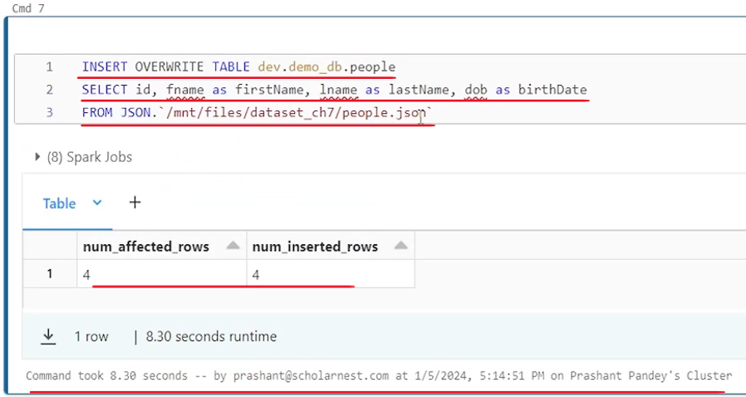

Let's say we want to implement some delete on the same delta table. So I am deleting one record. And then let's say I want to. Update some records, so I'm running an update transaction. Let's say we have a merge statement also. So I'm trying to implement a merge on the same data table. So what I'm doing I'm simulating various transactions on the same data table. We created a blank delta table and then applied a bunch of transactions.

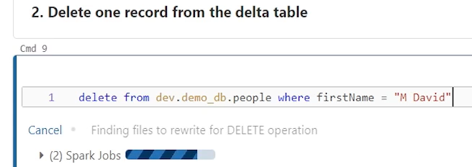

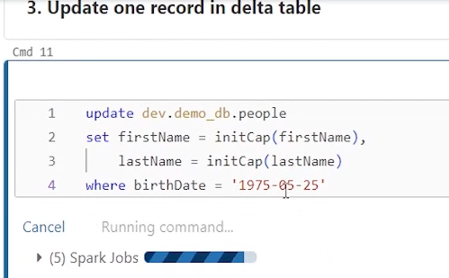

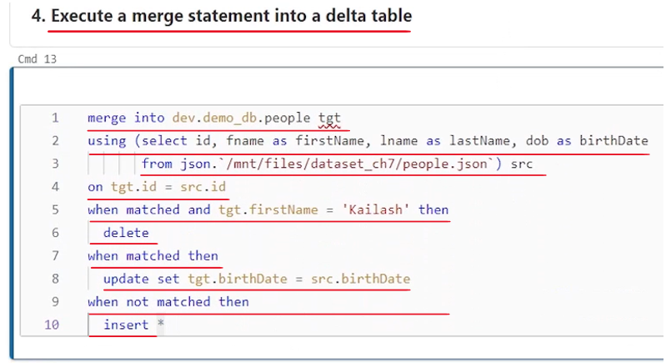

And what we know that delta table maintains versions and all the transaction information. So how do we see that version. Can we see the delta table versions. Yes you can. And it's as simple as describe. Describe history of the Delta table. Just give the delta table name. What is the Delta table name? This is the table. We are doing all the operations. So let's look at the history of this delta table.

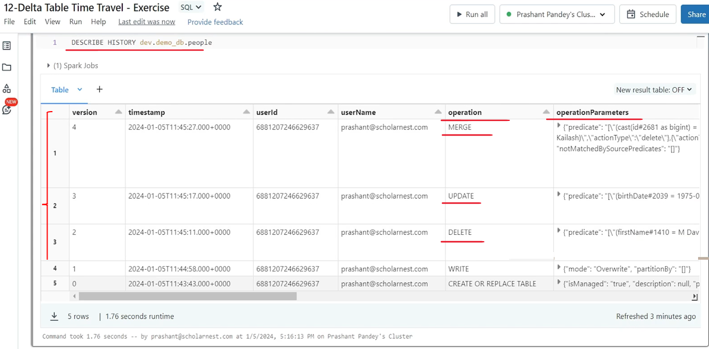

That's what we have. So we can see the delta table is version started from zero and it reached to version four are five different versions starting from 0 to 4. Why? Because I created five transactions. What are those transactions? You can see that here. The first transaction was create or replace table. That was my first transaction. I did that in the setup create or replace. So that created the version zero of the table. And then I did insert overwrite. Then I did delete. So all those transactions are also recorded. And a new state of the delta table is created which with each transaction as a new version. So write operation created version one, then delete operation created version two, update operation created version three and merge operation created version four.

And we also have a lot of other informations like what time this transaction happened? Who was the user? What is the user name? If there are any transactional parameters? if it was done by a spark job, what was the job? Which notebook, which cluster? All those details are there. So that's what the delta table history means or delta table versioning means. But you might be wondering what is the use of all this.

What is the use case. So there are many use cases.

The first and the most simple use case is you have an audit information on your table, right? You know who is doing what or what is happening on this table, how data is evolving or changing on your delta table. That's one simple use case.

Second use case is, for example, you want to build a report as on some date. For example, you are on fifth Jan, but you want to regenerate your report as on 31st December. So how do you generate a report as on 31st December, if you have generated it on 31st December and saved it somewhere, you can see it. But can you regenerate that same report as on 31st December? Very difficult because from 31st December onwards, your data keep on updating, keep on changing. You are doing a lot of transactions. So your table data is state is not as same as it was on the 31st December, but with versions and old states of data. We can do that. So that's another use case. So how do we query a table as on a old state. How do we do that. If we can do that we can generate reports as on 31st December or at as on whatever date you want.

So how do we query a table, or how do we query older versions of the table. Simple. you can do select star. From this delta table. the same delta table. And, if you run this query, you will get the result, set, which is for the latest data set. Right. Latest version. So whatever we are seeing here is the latest state of the data in that delta table, which is we know that version four is the latest. So whatever is state is at the version four. That's what we are seeing. And that makes sense. Also by default all your queries should return the latest state.

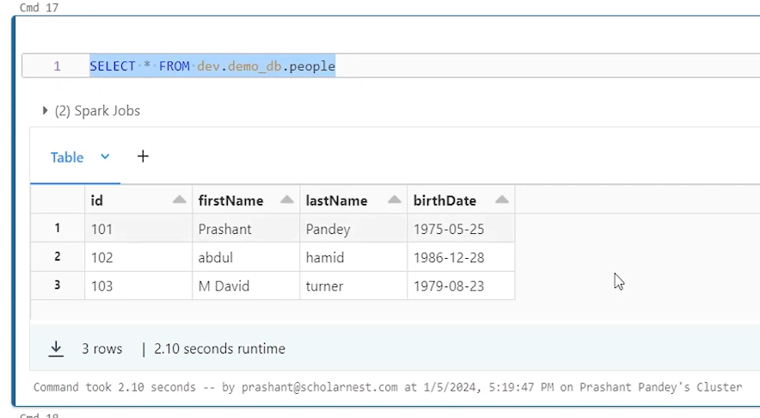

|  |  |
| --- | --- |
| But if we want to look at the older versions we should be able to do that too.  Also. And you can do it using your Select queries and then adding version as off. And then you can put whatever version name number you want. So let's say I want to look at the data at version one.  So version as of version one. And I can see four records in the first version. And what is the first version. First version. When we initially wrote, loaded the table with four records. So that's what I can see. |  |

So I can see as of any version as of version one, version two, version three like that. But version number is fine if we know the version number, which version number I want to look at, I can look at it. What about the timestamp? Can I query the data as on? 10 a.m. yesterday or 10 a.m. today. Right? Can we query the latest state as on a given timestamp? That is also possible simply in your SQL. Queries are very simple. Write it like this and then use timestamp as of and give a timestamp string. Uh. For example, let's say I want to query data as on this timestamp, right? Version three. The latest one is version four as on this timestamp. So let's copy this timestamp and um.

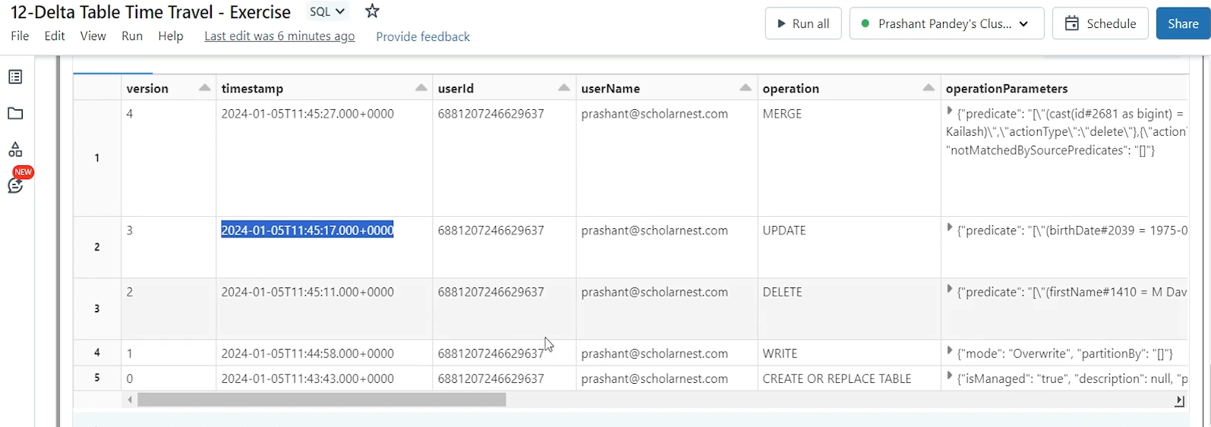

Paste it here. So this is the timestamp at 1145 17. Right. 1145 17 is the timestamp when version three was created. But how would I know the exact time of version? Right. It's not that easy. I have to look at the history and figure it out. So it's not necessary to give exact timestamp. I can give, 1145 17 I can give anything higher than this. I can give anything lower than this.

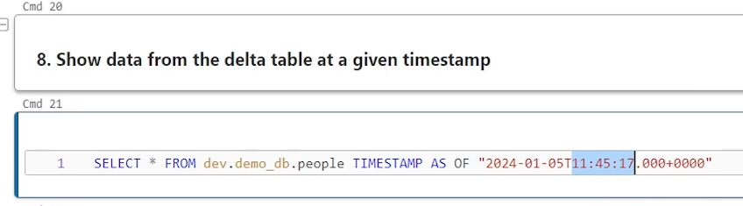

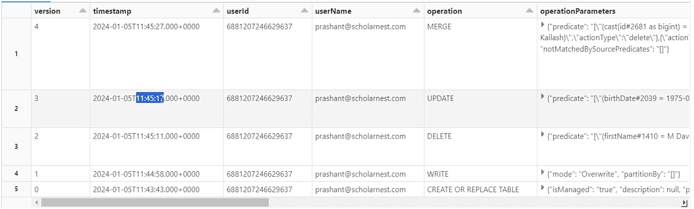

So if I give timestamp 1145 18. I, which is one second. above the version three. So it's this SQL query will result the latest version or latest state as on 1145 18. So what is the latest at 11 4518 version three. Right. 17 version at 4517 version three was created. If I look at the state at 1145 18, the latest version is three up to 1145 27 next version was created.

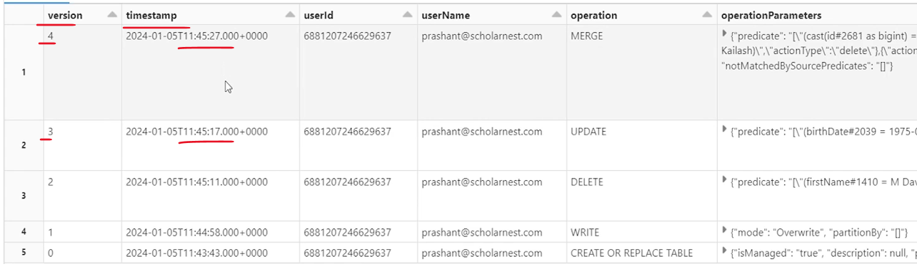

So between this and this time, whatever time I query, I will always see the version three, which is the latest version. So let's try querying at 1116. Right. This version was created at 17. I am querying at 16. So I should see version two after the delete. So I should see three records I guess. So let's query it.

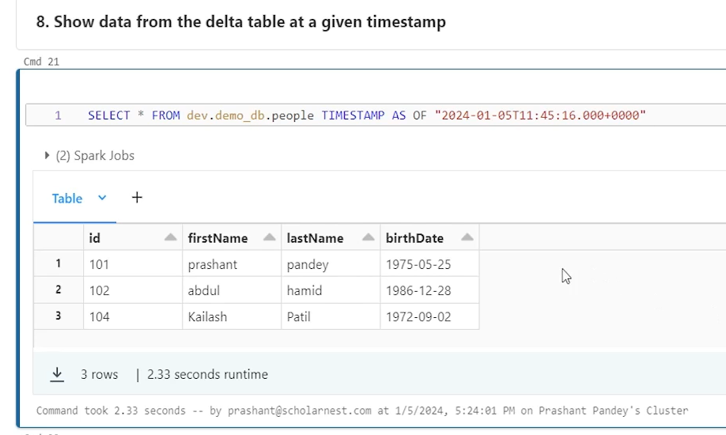

And I can see three records after the delete. So whatever is the state at this time is this query will give me the, data set at this point of time. So that's how you can create your old reports as on some time stamp. You can query your tables and you can generate regenerate your reports at that of time at that point of time.

|  |  |
| --- | --- |
|  | Another use case. what if I by mistake, delete a table or entire table or maybe some records? So let's say I have a delete from.  This table and I forgot to add a where condition, executed it and boom, gone. All three records are the entire data table is gone, if I try to query that now, let's say I try to query that now.  I will see nothing because I by mistake I deleted that or, I deleted something |

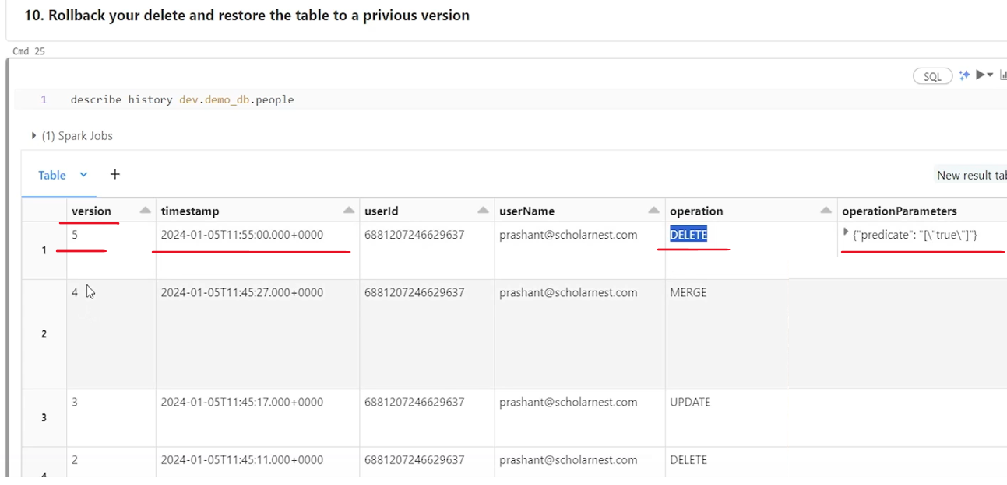

How do I get it back? So we know Delta table maintains different versions. you can look at the version, using describe. History. And on that table, you know, version five was created by this delete operation. And predicate is like blank, null, nothing. Right. So everything was deleted. Uh. Can I restore this data? So can I restore data for version four or. Anything after this time is damp or at this time is damp.

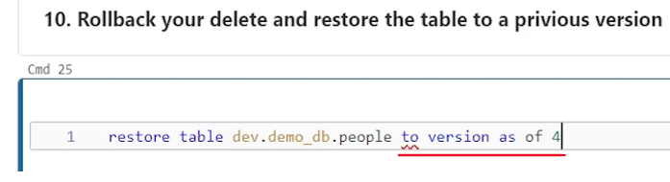

Yes, we can do so. How do we do the restore? let's try to restore. so statement is simple, SQL. Restore, write, restore and table name. Maybe you have to add table restore, table table name and two and two. You have both the options two version as of like this. Uh. Version as of. And let's say we want to restore to version four. So this should do. Or you can do two. Time stamp as off and then give the time stamp. And I know I deleted it at this point of time. So, maybe 1155, double zero, something. So 1150. 1154, maybe, 59 seconds, just one second before I executed the delete transaction. Can I restore to that point in time? Yeah, we can do that. Let's try it. And. It worked. It worked

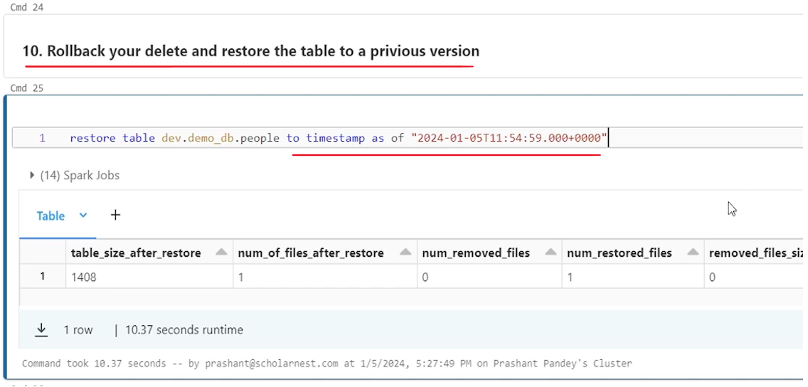

|  |  |
| --- | --- |
|  | And, if you want to see now, once again, let's say select star from this table, it should show me the data. Right. Because table is restored, that delete operation is gone.  But it is not like that. History is not maintained for restore. Look at the describe. History. So, in the history we will see a version six is created by the restore operation. Right. And some more details are there operation parameter was this timestamp. |

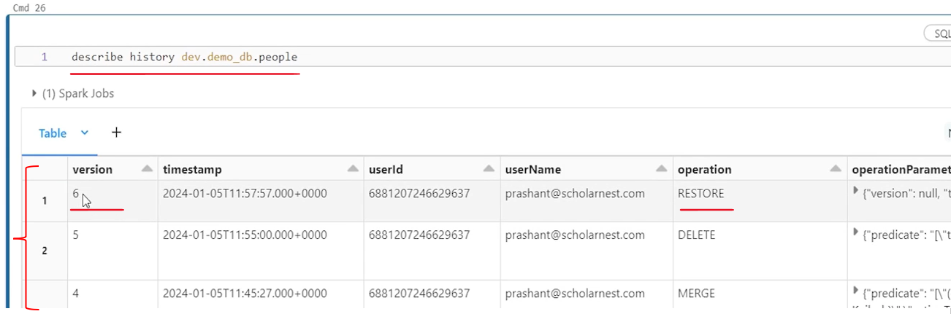

So we did a restore and that also is logged audited. So that that's what are the benefits of delta table versioning. You have multiple use cases for that. You can query at a timestamp and regenerate your old reports. You can restore tables or data set to a past time stamp or version. Or you can also use the, history for the audit purpose. That's all about, versioning. But we learned all of that, using a spark SQL. Can we not do these things using Spark Data Frame API? Yes, we can do so. Read version one of Delta table using DataFrame API. Can we do it? Yes. so this is the code spark.read and you tell table give the table name. It will return the data frame. Maybe you can display it. But we want to read as of version one. So you can give an option. We have an option with the delta table where version as of one I'm not telling format here. Maybe format is optional in Databricks. default format is delta. Uh. But you can tell Delta? So, but if you don't tell format, it is assumed to be Delta.

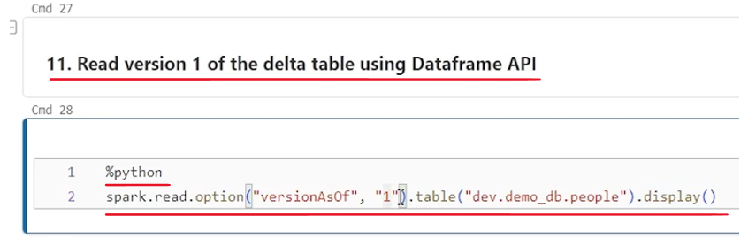

So you can run this version as of and read the version one of the table so you can do it from the, spark SQL spark data frame API also. Next thing is read delta table version as a given timestamp using data frame. So same same approach. Only the option will change. we learned how to read at version as of, but if you want to read it at timestamp as of, you can set the option time stamp as of and give a time stamp here.

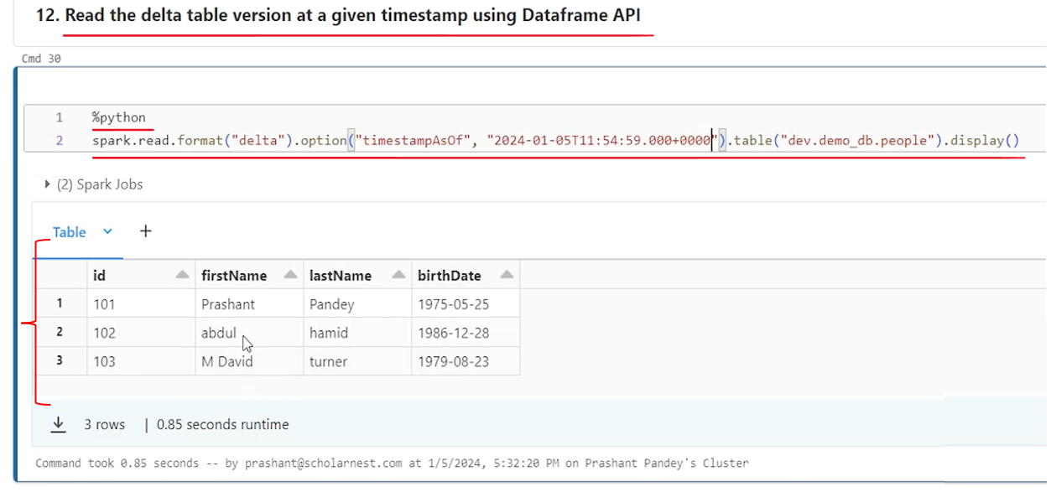

So let's say we want to. May be read at this timestamp. Right? You want to read at this time is time. So let's try that and it should give you the data at this time is time. So that's how we can read. can we restore data using data frame API? No. Data frame API doesn't give us an option to restore data to a older version. A Delta table API does give an option. So if you have a requirement to write a restore operation in Python, you can use Delta table APIs. If you can manage it with spark SQL like this. this is an easy option, but if you have a compulsion to do it in Python, you can use Delta table API. So we have used delta table APIs earlier. How to use it from Delta you have to import table. Maybe this is a SQL cell. So import, delta table and then maybe create a delta table object. Uh. What data set we are creating people data set. So let's say. people_dt equal to delta table.forName and pass a spark session and then pass the table name. This is the table Name and you got the people.dt and then use people dot to implement restored to let's say version. And let's say I want to restore to version one. that's how you can do it in, Python using Delta Table API.

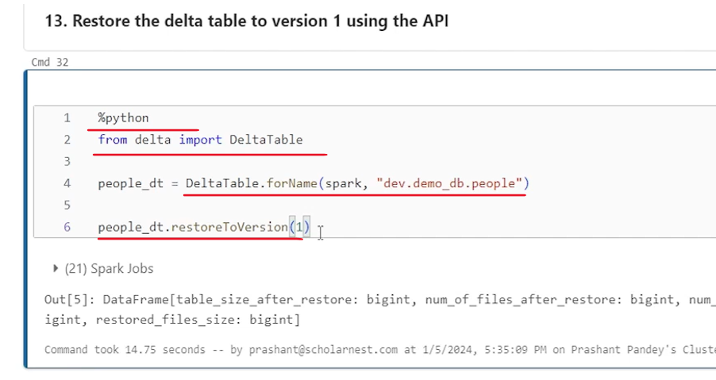

Similarly, you have a method for restore to timestamp. you can use both or whatever you want, and you can restore to any other version using Python code. So that's all about, delta table versioning and time travel.

### Convert Parquet to Delta

We will learn how to convert parquet data set into a delta table or delta data set. So let's get started. So let me go to my workspace. I have a notebook setup for this. Um. Here. Let's connect to the. Cluster. Do the clean up. And then run the setup. So basically what we are doing in this setup I am creating a. I'm creating a volume. Basically, I'm creating a catalog and in catalog I'm creating a database, and in the database I'm creating a volume. Volume is just a directory. You know, you can create data files in that. And then in that volume, in that volume I'm creating a parquet data file. I'm manually creating it for this demo.

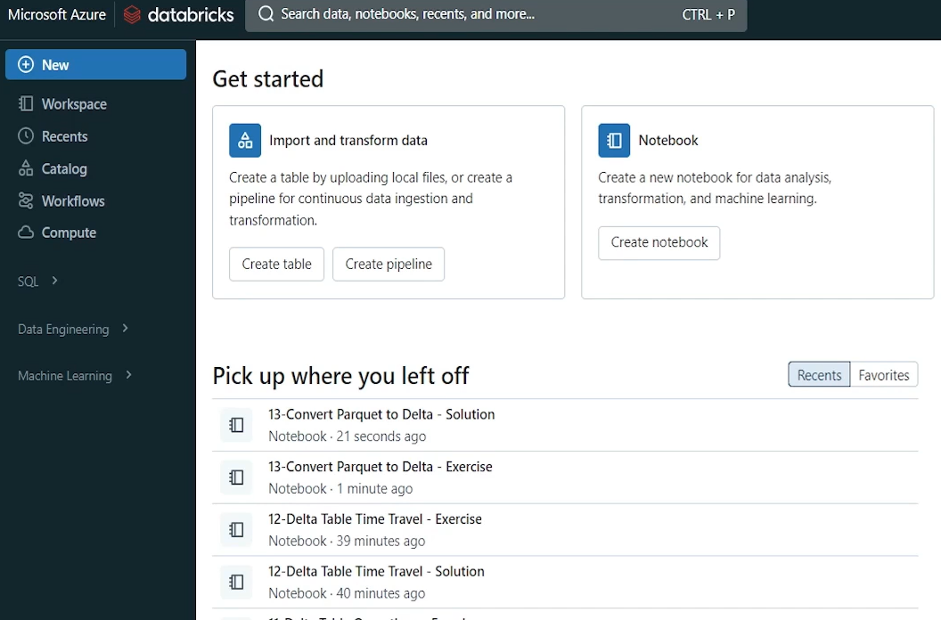

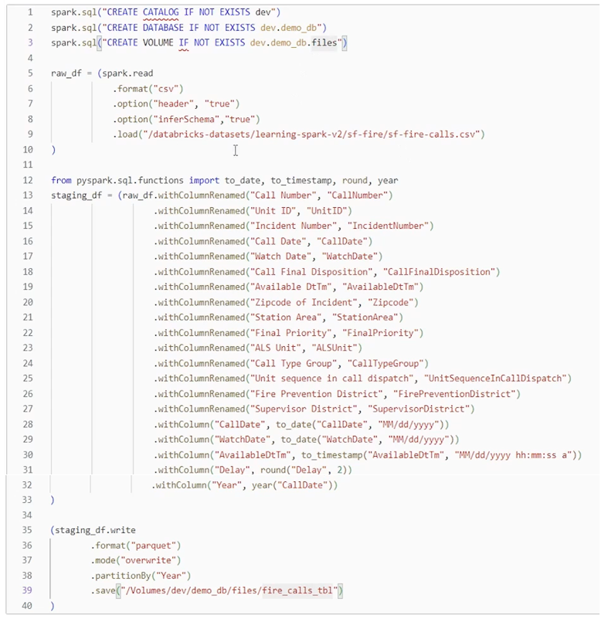

So the point is that we have a parquet data file. And we want to convert it into delta table in place. So how will you do it? So one way to convert a parquet file into a data delta table or delta format data set is to read the parquet file into a data frame and maybe save it into a delta table, or save it as a table. And using the delta table format and your parquet file is converted into a delta table. But you are duplicating data, right? You are reading parquet data file and then writing it as a delta table. So that's a duplication of effort, which takes a lot of time.

And we know that delta table also stores data as parquet data file. So if you already have a parquet data file you can simply lift it to a delta format or to a delta table. So delta table gives you a tool for that. Let's try to learn how to do that. So let's look at the file. first I will simply use the fs ls command. So. This is my fs ls command. And this is the directory where I have some, parquet data set. So this is my parquet data set. you can see it's a partitioned data set, in parquet format. So this is my base directory, fire_called_tbl.

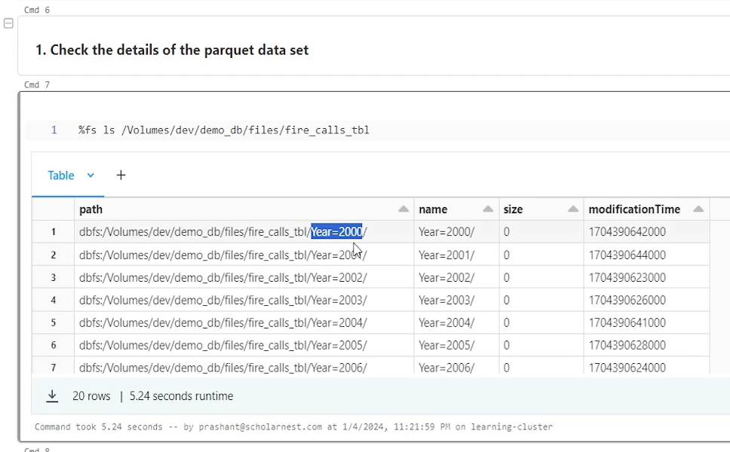

And in that directory I have data set which is partitioned by year. Right. And that's what I created here. partition by year. Right. So let's assume you have a partitioned data set. and if you look inside any of this, maybe. 2000, you come inside and you will see some. Data files. And this is your parquet data file. And you have usual I start commit success. All these are part of the parquet data set.

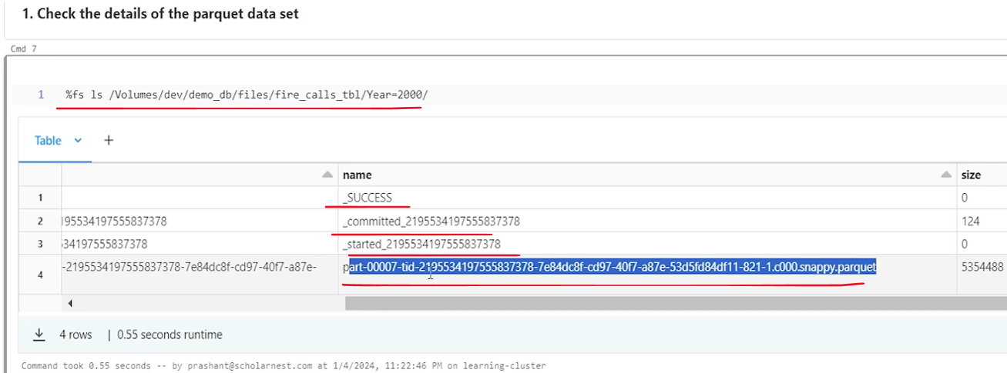

So this is what we have, what we want to do. This partitioned parquet data set. We want to lift it to make it delta table or delta data set. So how to convert this parquet set into a delta data set. We have a tool for that. Let me try to help you that it's an SQL and you can use convert command convert to delta and just tell the parquet table location. So this is the location, right. So we tell it using maybe uh. Park dot and in pair of backticks we tell the base directory location and it should convert this parquet data set into a delta data set. But we know that parquet data set is partitioned. So we will have to tell that partition information also along with the convert to delta. So we have to tell that. Partitioned by and tell the column name on which this is partitioned. So. Column name is here, right. So it is partitioned on the column. Here. And we will also have to tell what is the data type of the air column. So I'll tell what is the, uh. Data type of the year and we can run it. That is all done. So what happened? This parquet data set is now converted into a Delta data set in place at the same place.

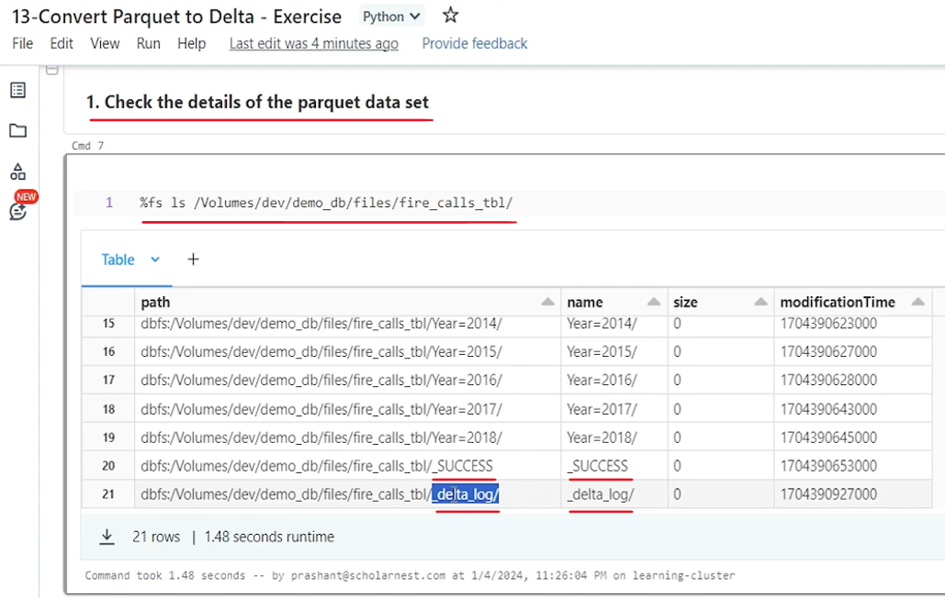

So earlier when we did a list on this directory, we saw partition directories and success directory. That's all because it was a parquet data set. Now it has become a delta data set. So if you list this you will see your partition directory success directory as usual the earlier ones. And you are also seeing a underscore delta log directory. So what spark has done or Delta Lake has done. It has created a delta log directory where some transaction information is saved. And now this data set is a delta data set. So if it is a delta data set we should be able to see the version history of this data set right. So let's query the version history how to do that. maybe change it to SQL. And we can use describe. History, command and history. On what? On the Delta table. But we haven't created a delta table. What we did here, we converted parquet data set into a delta data set. There is no table created yet. There is no metadata yet. but, we can access the Delta data set also, like a table.

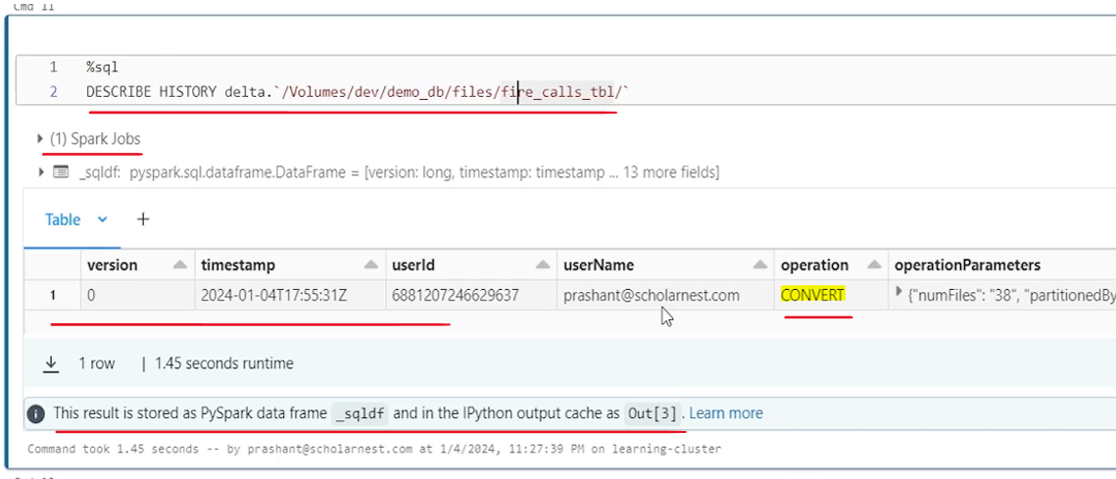

So we can use delta. in a pair of backticks we can tell the location. And describe the history. And if you look at the history. You will see version zero is created using the convert operation. So from here onwards, if you do any operations or any transactions on this data set. Delta table will keep on creating new versions. so that's how you can convert existing old parquet data set if you already have some parquet data set in the old projects and you are migrating to, Delta Lake, you can easily migrate your data set in place using the convert command.

### Delta Table Schema Validation

So far we learned a lot of capabilities and features of delta tables. Now in this lecture we want to learn delta table schema validation capability. Delta tables were designed with an thought in the mind that delta table will store structured data. Structured data always comes with a predefined strict schema. So there are some additional schema validation capabilities built inside the delta table. So in this lecture we will try to understand what are those schema validation capabilities. Let me go to my workspace and in my home directory I have set up a notebook for schema validation. will come to the notebook. The code is already written here, because all the code that we are going to use here is simple enough. Mostly spark SQL and some data frame API code. So I'm assuming that you already know the code. So I'm not going to type that here. So let us do the cleanup before we start anything and then we will do some setup. So basically what I'm doing I'm setting up a small simple delta table with just three columns ID, first name, last name, id is integer, and first name and last name are a string. And we want to understand how a schema validation capability of delta table works. So for schema validation we will have to understand few basic things before we talk about schema validation. What is schema validation? It is as simple as that.

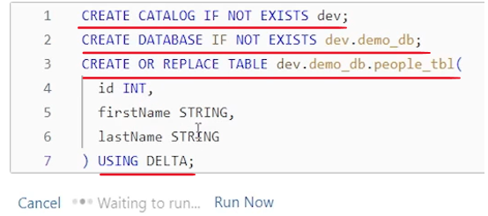

|  |  |
| --- | --- |
|  | When you try to insert records in an existing delta table, the delta table will validate the data type, column names, all those schema details of incoming data. So if the incoming data is schema of the incoming data matches with the target table wherever you are trying to insert, it will allow you to insert new records. But if there are any discrepancies, if a schema of the incoming data does not match with the target table, it should raise an schema validation error.  And the point is that schema validation comes into play when you try to insert records into an existing delta table. That's the time when schema validation triggers, and how many ways we can insert data into a delta table. You can use insert statement, spark SQL insert statement. You can use insert overwrite statement, spark SQL insert overwrite statement. You can also use merge statement merge when not matched, insert right. So merge statement also allows you to insert new data into an existing table. So you can use merge statement. And you can also use data frame APIs. |

Save as table method with append mode which will insert data into an existing table. So these are four ways we can insert new data into an existing table. And what are the schema validation scenarios?

There are three scenarios I have listed here. The first one is column matching approach. So when you try to insert a new data set into an existing delta table, the column names should match. Or maybe column matching can work by column position. So how Delta table works? We will try to understand how the column matching is validated by the delta table. The second scenario is you are inserting some new column. So for example you have a table with ten columns. But when you are inserting new records you are inserting 11 columns or 12 columns. So what happens with the new columns. So that's another scenario where schema validation will trigger. The last scenario is data type mismatch. So if you have a delta table you have let's say ten columns. All columns are defined with the proper data type. And you are trying to insert new records into those, tables, those columns. What if the data type mismatches. So that's another schema validation scenario. How delta table works in those scenarios we will try to understand. So let's start with the first scenario where you are trying to insert data into an existing table using the Insert statement. And for Insert statement we will try to understand these scenarios.

So here is an example. We already have a people table already created here I have created this people table. There are three columns ID first name, last name. And now I am trying to, insert some new records into this people table. So what I am doing, I am reading people.json file, and from that file I am building a select statement which will insert data into this table, but I am using different column names. The select statement comes with id Fname Lname three columns, but names are different. The table has got id first name, last name. So we have a difference in column names. What will happen? What is going to happen. So let's try running it and we will see the results. It worked. I was able to insert four records into this table. despite of the fact the column names are not matching, column names are different in the target table, column name is first name, but in the source column name is F name. But it worked.

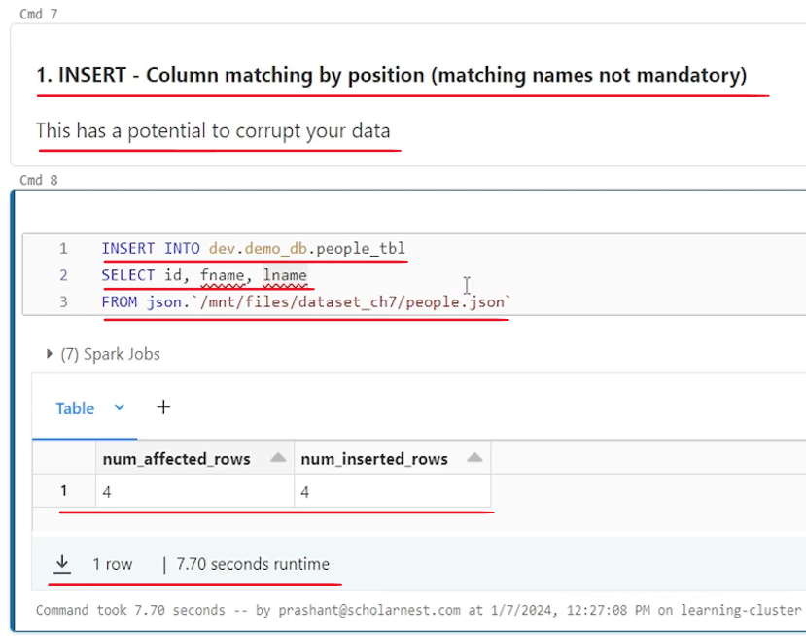

So conclusion is with the insert into statement, column names are matched by the position. Columns are matched by the position, not by the column name. So conclusion is column matching by position in the insert statement. Matching names are not mandatory, but this has a potential problem, right? What if you are inserting date of birth here and phone number here, right? The date of birth will go into the first name, and phone number will go into the last name. So this approach has a potential to corrupt your data, because schema validation in the delta table is not there in place for matching the column names. As long as data types are matched, it will allow you to insert it. So be aware with that fact.

The next scenario is for the insert statement. What if we have got a new column. So in the same people table I am reading data from the people Json again and inserting id, fname, lname and DOB. But in the people table we have only three columns. And will it work? Will schema validation trigger? Let's try it and you will see a exception a schema mismatch detected. Right. So schema validation is in place. If you try to add extra columns even using insert into and the error message will clearly report that schema mismatch is detected. This is your target table schema three columns. And this is your, data schema which is four columns. So schema is not matching. So this is not allowed. That's a schema validation is in place.

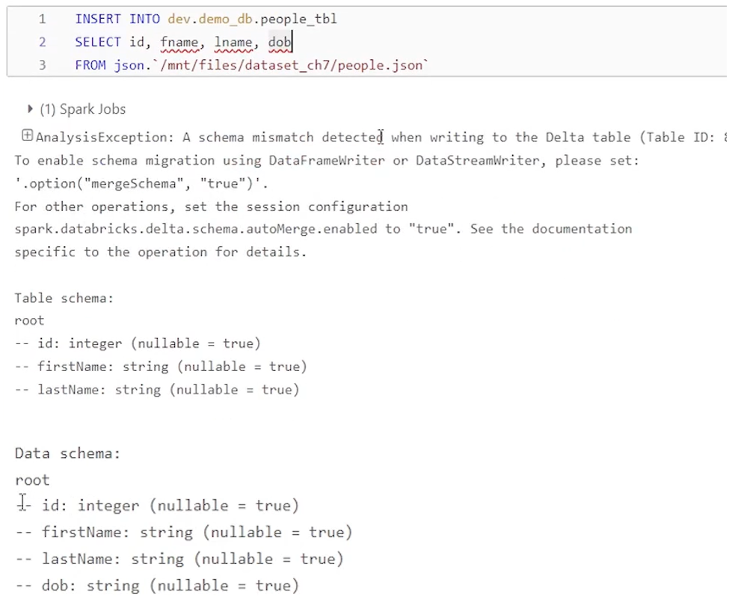

And which is a good thing. Now what if I try to overwrite this table and insert four columns instead of three old columns. So this table has got three columns. And we want to insert four columns. I don't care about the existing data. I want to insert new data overwriting the table. Is that allowed. Let's try that here. So here is a scenario where I'm trying, insert overwrite on the people table and trying to insert four columns. So schema is already there with three columns. But I'm trying to insert four columns. And I also want to overwrite the old table, delete it kind of and then overwrite it. Is that allowed? Now that is also not allowed by schema mismatch detected. And that's a good thing because it's a delta table. And delta table maintains different versions of the data.

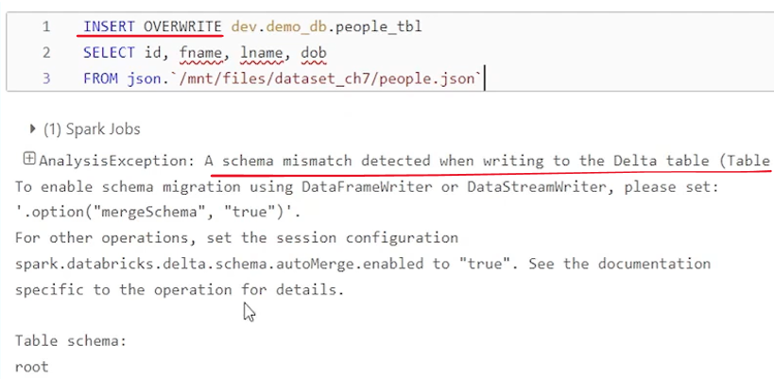

Even overwrite will create a new version of the same table. It's not like that. It's we are dropping that table and recreating it from scratch. Overwrite is overwrite the existing table with a new version. And that's why we have an schema validation in place for overwrite also. And then finally let's try to understand merge. So what happens when we merge. and column names are not matching. So that's the scenario. So to test that scenario I have created this select statement. So basically I have data in the people two dot Json file which I am reading this, using this Select statement. And I got id f name el name three columns. Right. And I want to merge this into people table. That's my target. Will that work. It should work because it worked with the insert into right? We know that column names are different in the people. table we have column names like ID, first name, last name, and we are inserting three columns. column names are different, but it worked with the insert statement insert into. So it should work with the merge. Right. But let's see if that works. No, it doesn't work. Cannot resolve first name in insert class given that blah blah blah. It's error message is a little different, but there is an schema validation in place. It throws an analysis exception and it doesn't allow me to insert into this table because the column names are not matching. So that's a good thing.

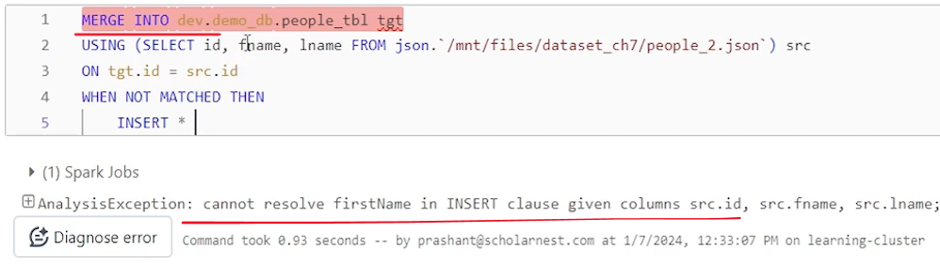

It avoids potential data corruption problem. Ideally, insert into should also allow this kind of schema validation in place and stop us from inserting records where column names are not matching, but is insert into allows that insert into works on the column position which is a potential problem, but if you try to merge, it will throw an error helping you to protect yourself from corrupting your data because you are. Inserting wrong values into wrong column. So merge statement comes with the schema validation for column names. Similarly, what happens if we try to add new columns in the merge statement? So. Let's say I have a people two dot Json file and I'm trying to read, id f name as first name. So the column names are changed. I don't want to get column name validation error l name as last name. The three columns, the problem that I had here, I have fixed those problems here in this SQL to match the column names, but I am adding one more extra column, which is date of birth. So can I use this select statement to merge data into the target table. So here is my target table. That's my people table with three columns. And I'm using this select statement which results into four columns. First three column names I have made sure they are matching. The last column is extra column. Can I insert it using insert star when not matched? Will it work? Let's see. It does not throw any error. So it looks like it worked.

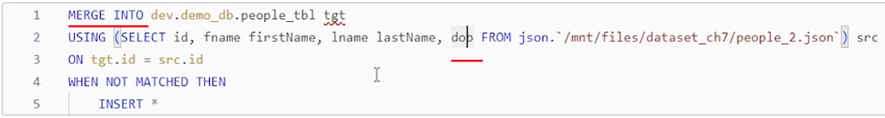

But let's look at the table. What happened actually, did I get the extra column? No, I still have only three columns ID first name, last name. I tried to insert this extra column date of birth DOB column into this table using the merge statement because I am using merge insert star, so everything should be inserted, but merge statement silently ignored the extra column and didn't throw an error. So that is also a potential problem. In the merge statement I. Schema validation is there in place for column names in the merge statement, but it silently ignores the extra column doesn't insert it. So which is half good? So that's about the merge, new columns are silently ignored.

Now let's come to the data frame API. So in data frame APIs what happens? So I have this scenario here, where I'm creating a schema I schema name schema definition is id fname lname. And I'm trying to read data frame, a Json file which is people two dot Json using this schema and create a data frame. So this data frame will have three columns id f name and l name. And then I'm trying to write this data frame in the append mode using save as table into the same people table. delta table. So that's my delta table. So what I'm doing I'm using data frame API to insert. New records into an existing table, but column names are different. The table has got ID, first name, last name, but my data frame has got id Fname Lname. Will this work? This worked in insert statement right? Insert into allowed us to do that because insert into worked with the column position. But what happens if we try that. Same with the data frame API. Let's try that. Schema mismatch detected and what is the difference ID first name last name.

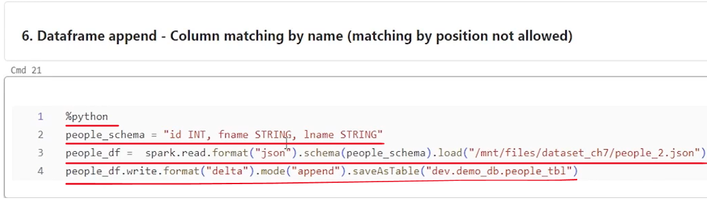

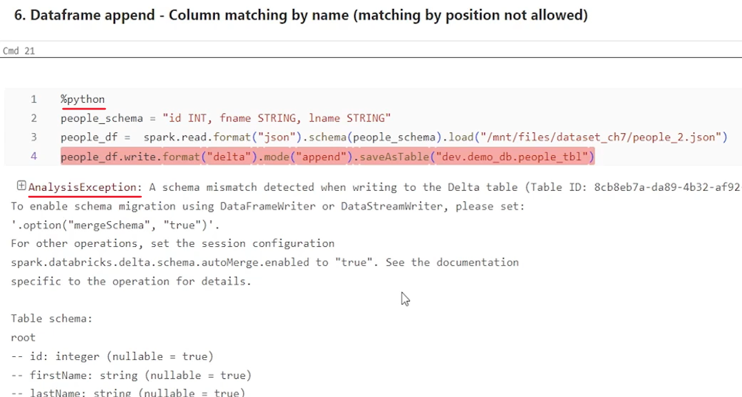

And here we still have three columns but IDF name l name. So column naming must match. If you try using data frame API to insert new records or append new records in an existing table. So the problem that we had in potential problem in insert into R is taken care of in the data frame API. So column matching by name works in the data frame API. Now last scenario, what happens if we try to insert new columns into an existing data frame? So here is the scenario. I am again reading data from the people two dot Json and I am reading four columns here. First column is ID, second column is first name, then last name, and then DOB. Right. So first three column names are matching in the target table. But I have an extra column here. Will this work. It didn't work with the insert statement also. Right. So it should not work with the data frame API. I schema mismatch detected. So that's all about schema validation.

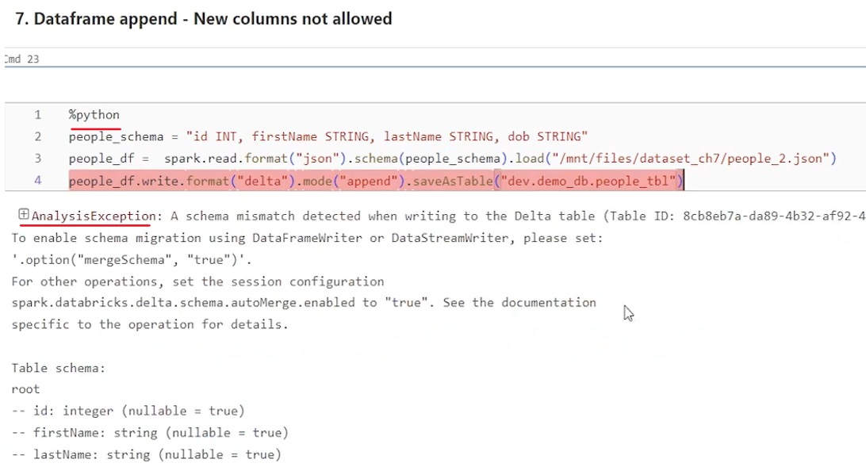

Let's come back and quickly summarize what we learned, because it looks like schema validation is little weird in delta table. Okay. So I have added, summary here in this notebook as a documentation. So what we learned that there are four approaches for inserting new records into a existing table. And there are three scenarios, for schema validation. So I have tried to summarize everything here.

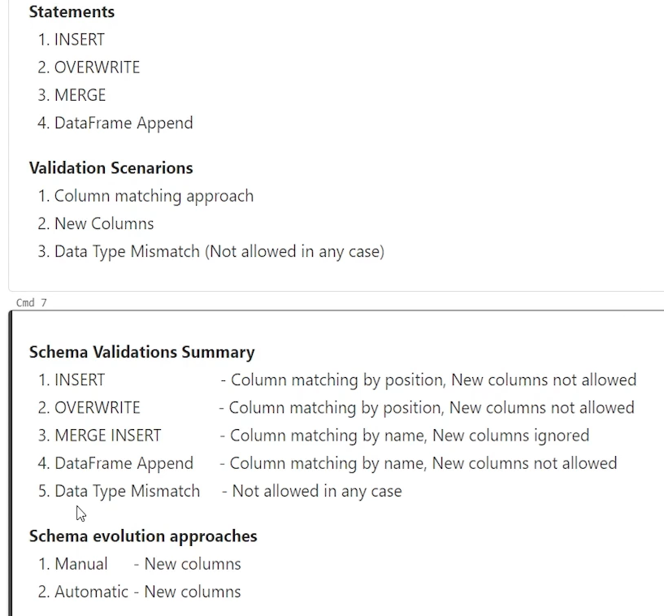

So with the insert with the insert statement column matching by position is the way right. delta table will try to match column by position not by name. So in some cases it is allowed if the column numbers are matching in the insert statement. But new columns are not allowed. Right. New columns, are not allowed to insert into an existing table with overwrite column matching by position is the way. So like insert overwrite is also insert overwrite. So columns are matched by the position but new columns are not allowed. Adding new columns are not allowed. That will throw an schema validation error

With the merge insert star, column matching is done by name. So column names must match and new columns are ignored. So we have a problem here. And we have a problem here. It's not a very strict schema validation in data frame append, which is kind of perfect. Column matching is done by name and new columns are also not allowed. So data frame append mode is the best approach for inserting new records into an existing delta table, because it has a full proper schema validation in place, which will help you to protect your tables from being corrupt or data being ignored without you knowing that some data is being ignored. So data frame is the best, option here.

And last thing is what happens if data type is mismatched. So no matter what approach you are using, whether insert, insert, overwrite, merge or data frame append data type mismatch is not at all allowed by. Any way in any of the approaches. I didn't had a, example to show that because it works everywhere. so always remember that data type mismatch is not at all allowed. It's standard strict. So that's the summary of the schema validation. You should always remember that Insert has an exception here for schema validation. Insert overwrite also has an exception here. It's not very strict. Schema validation. merge has an exception here. It's not very strict, but with the data frame append. Schema validation is very strict. It doesn't allow you to, corrupt your data or, go things unnoticed. And that's all but what if we have a requirement, right? What if we have a requirement to, add new columns? Accept new data into our existing delta table. And that's where we, look for schema evolution approaches. So we have two schema evolution approaches manual schema evolution and automatic schema evolution.